Welcome to the April EduExe newsletter!

The EduExe newsletter is an initiative for all colleagues involved in education, focusing on news, updates and all things educator development and enhancement. This monthly newsletter will include relevant articles and resources according to the time of the academic year, updates on strategic projects, reminders of key deadlines (i.e. for module amendments) and much more!
If you experience any accessibility issues with this email, you can access a word version on the EduExe Toolkit.
This issue we have a special focus on disability, including:
- Update on Inclusive Education Project and Universal Design for Learning (UDL)
- Student perspective on inclusive education
- Case Study: supporting checklists
- Neurodiversity Cafe & Body Doubling
- Signposting students to Wellbeing and AccessAbility services
- Arranging an Individual Learning Plan (ILP)
- Creating accessible content
- Supporting Neurodivergent PGRs, their supervisors and their examiners
- Feedback from Neurodiversity Celebration Week
- Existing case studies and resources
- Professional developiment teaching in sustainability survey
- Students as change agents call
- THE Campus call for content
- Upcoming events
- On EduExe socials this month
- EduExe Only Connect – the answer
- April Challenge - The EduExe Cryptogram!

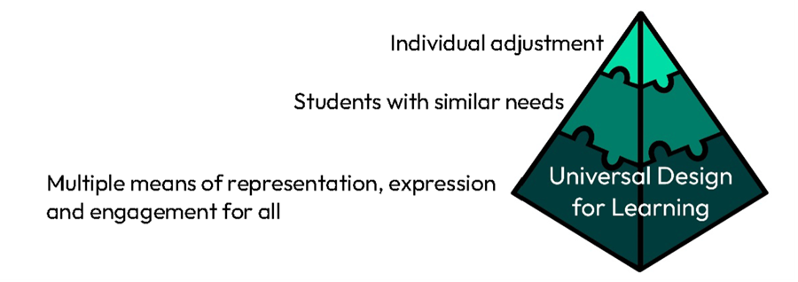

Update on Inclusive Education Project and Universal Design for Learning
Over the past 18 months, Professor Vrinda Nayak and Rachel Griffiths have been leading the Inclusive Education Project. Driven by key inclusion priorities in Strategy 2030 and the Transformative Education Framework, the project was established to review our current support for disabled students and explore the potential for Universal Design for Learning (UDL) to improve our teaching and learning practice. We finished the first stage of the project in summer 2023 and made a series of recommendations that we are now taking forward. A copy of the report produced at that point is available on request from Rachel Griffiths (r.griffiths@exeter.ac.uk).
Our project findings support the move across the sector towards embedding UDL to support the needs of an increasingly diverse student population.
What is UDL?
UDL is a design process that focuses on facilitating multiple ways of engagement, representation, and action and expression from the outset, eliminating barriers through an approach that considers the needs of diverse people, rather than retrofitting solutions or implementing individual adaptations. The design learning principles ask questions like these:
- What barriers are your learners likely to face?
- What are your learning goals or outcomes?
- What teaching and learning tasks will you set?
- How are you going to set those tasks?
- What resources do your students need?
- How are you going to present those resources?
- How will you know that all learners have met your intended learning goals or outcomes?
Find out more about UDL
How does UDL fit with students’ Individual Learning Plans?
UDL is not a panacea, and bespoke reasonable adjustments will continue to be required by some disabled students, so we are adopting a two-pronged approach: to secure effective implementation of ILPs for students who declare a disability, and to move towards a position where ILPs are no longer the only means of overcoming educational inequities faced by our students.
The diagram below illustrates this continuum of solutions. We want to move to a position where the direction of travel is downwards from reliance on individualised, ad hoc adjustments, towards systemised provision for all.
To support this, the Educator Developer, Learning Design, and Wellbeing teams, together with the Neurodivergent and Disabled Students Society, have created a 90-minute interactive workshop for teams of educators or Professional Services staff with any kind of teaching role. In the workshop, we will take some intended learning outcomes and, using the "design backwards, deliver forwards" process, explore some practical solutions to the questions above.
If you are interested in booking a session for your department or team, please contact the Educator Development team (eduexe@exeter.ac.uk).
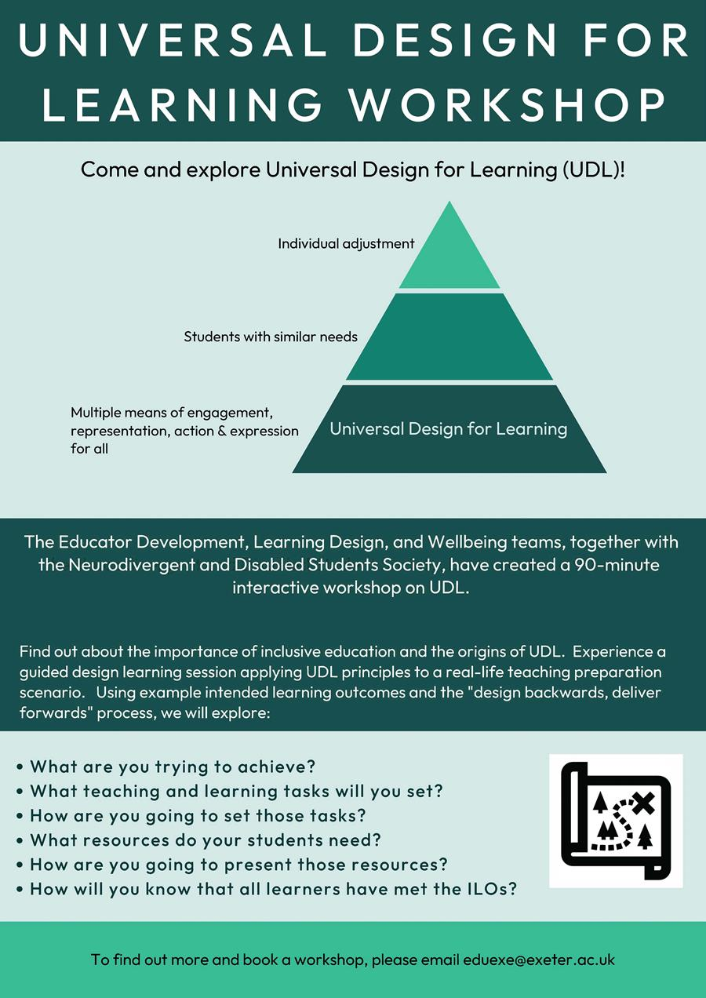

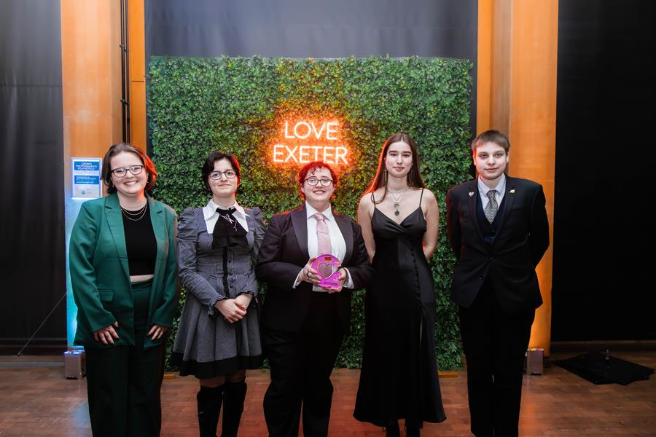

Student perspective on inclusive education
Ellie Sokhn, member of the Students' Guild and Co-President of Neurodivergent and Disabled Students Society (NDSS), has written the following blog from a student perspective on inclusive education and the importance of role models.
Many of us have had the experience of meeting someone who gave that extra bit of support needed to get through education. An English teacher who paid particular attention to your difficulties with writing, or a university professor that went out of their way to advocate for your accessibility needs. Being a role model to students changes the way they interact with their education: for example, studies show that female college students are more inspired by female than male role models. Here are a few ways you can lead by example as an education provider:
Include disabled people in your course material:
Course content often either includes disabled people in a dehumanising way, such as discussing whether they bring value to society, or doesn’t include them at all. Focus on normalising the existence of disabled people as feeling individuals, rather than theoretical case studies. For example, in a philosophy class, provide specific dilemmas that involve disabled people, such as embodiment or self-perception. In medicine-based classes, include examples of how healthcare impacts disabled as well as able-bodied individuals, such as medical negligence, and so on. This helps students feel represented on a day-to-day basis, rather than outsiders that aren’t included in the norm. It also demonstrates a recognition of the particular struggles they face, which helps create a safe learning environment.
Help your students see you as a safe and trustworthy person:
Make sure disabled people aren’t excluded from your classroom: for example, wheelchair users often sit at isolating desks, or screens and presentation slides are often too bright and cluttered. Ask your students what accessibility needs they have and do your best to accommodate! If there is nothing you can do to accommodate their needs, communicate this as well: disabled people need to plan for obstacles they will face as well as what accommodations will help them. This is important in making disabled students feel respected and perceive your classrooms as a safe space to freely express their needs.
Advocating for disability rights within your university or school:
While advocacy can be challenging, especially within the workplace, creating a space for inclusive education is a task for institutions to tackle as well as individual people. Understanding your students within your classroom comes hand in hand with helping push for accessibility outside of it: this can involve reporting issues such as broken automatic doors, or signing petitions against newly inaccessible buildings. Actions like these go a long way in role modelling inclusive education and leading by example, through active participation in favour of the disabled community. It represents genuine care for your students, and encourages them to also vouch for accessibility, whether they’re disabled or not.
Whether you take small steps or big ones, any change towards more inclusive education is a positive sign. Most importantly, listen to the disabled community first, and respect their voice as a mandatory part of creating a more accessible world.
Some thoughts from disabled students:
“I always struggled with feeling lazy or incompetent. Professors that went above and beyond to show me understanding are always remembered and encourage me to push forwards whilst still being kind to myself.”



Case Study: Supporting Checklists
We heard from disabled students that one of the most helpful things we can do is to support them to structure their learning.
Professor Layal Hakim, Co-Director of Education and Student Experience in the Department of Mathematics and Statistics, Associate Professor (E&S), has written the following blog on how she supports students through clarity and consistency:
In recent years, as we strive to make education more accessible, there has been a growing recognition of the importance of supporting neurodiverse learners within educational settings. From classrooms to lecture halls, creating an inclusive environment is not just a moral imperative but also enhances the learning experience for all students. Here are some general tips on how to support neurodiverse learners effectively:
Clear Module Expectations First and foremost, clarity is key. Clearly outline how sessions are run and how the module will be assessed. Providing a roadmap helps neurodiverse learners navigate through the course with confidence.
Preparation is Key Provide full slides and notes before lectures. This allows neurodiverse learners to familiarise themselves with the material beforehand, reducing anxiety and increasing engagement during the session.
Consistent Templates Utilize consistent templates for lecture slides or notes. This includes using consistent headings, colours, and labelling. Predictability in format helps neurodiverse learners focus on the content without unnecessary distractions.
See an example from Mathematical Methods
Why not try this template format for your lecture notes, or to encourage students to organise their own notes?
Minimize Visual Stress Aim to minimize visual stress by using larger sans-serif fonts, increasing line spacing, and avoiding overcrowding of information on slides. Creating a visually comfortable environment enhances comprehension for neurodiverse learners.
Clarity in Communication Use clear and consistent notation and terminology throughout the course. Additionally, make questions explicit by highlighting assumptions and the desired outcome. This clarity aids neurodiverse learners in understanding the tasks at hand.
Step-by-Step Instructions Provide step-by-step instructions whenever possible. Breaking down tasks into manageable parts helps neurodiverse learners approach complex problems systematically.
Offer Multiple Methods Recognise that different methods may be suitable for solving the same problem. Provide alternative approaches to accommodate diverse learning styles among students.
Break Tasks Into Parts Break tasks into smaller sections to prevent overwhelming neurodiverse learners. This approach facilitates incremental learning and reduces cognitive overload.
Visual Aids Incorporate diagrams or schematics alongside textual information. Visual aids can enhance understanding and retention for neurodiverse learners.
Respect Individual Needs Respect individual needs without question. If a student needs to leave the session or uses ear-defenders or headphones, honor their preferences without judgment.
Assessment and Feedback When making adjustments for neurodiverse learners, ensure they are suitable and effective. Consult with the student directly, as not all accommodations are documented in an Individual Learning Plan (ILP). Be mindful that repeatedly explaining one's condition or requirements can be draining for the student.
Meeting Etiquette In meetings, provide reading materials in advance if relevant to allow neurodiverse learners to prepare. Clearly communicate the purpose of the meeting and stick to the agenda as much as possible. Be attentive to the needs of all participants, offering breaks when necessary. Seek alternative methods to encourage participation from neurodiverse individuals, ensuring everyone has a voice in the discussion.



Body Doubling and the Neurodiversity Cafe
Lena Worwood, EDI Project Officer, provides information on ‘body doubling’ sessions run by the Neurodiversity Cafe:
Body doubling is a method of getting through potentially frustrating tasks by doing them alongside other people for a focused period of time. The method comes from the ADHD community but is usable by anyone who finds it helpful. There's no one correct way to do it, but in general it involves setting an intention to get something done, then working on it alongside other people who have their own work to do. For many people, especially ADHDers, supportive peer pressure, a focused amount of time, and a friendly group can make it much easier to focus and get things done.
Watch this YouTube video for more information on body doubling
The Neurodiversity Cafe runs body doubling sessions alternating Wednesdays and Fridays. In a normal session we check in at the start, and the end, and midway through we check in on how things are going. We've found body doubling works better for us if someone has their camera on, but doing so is not compulsory.
There are body doubling sessions running in other groups in the University, and some people have found it more helpful to make arrangements to body double one-on-one with someone else. This can be a colleague, a friend, or someone from the Neurodiversity Cafe.
The Neurodiversity Cafe can provide support for people wanting to try body doubling, or who wish to set it up for their own group. You can join our sessions by signing up for the Neurodiversity Cafe, or if you'd like to have a chat about body doubling and how to make it right for you, please email Lena at s.worwood2@gmail.com.



Signposting students to Wellbeing and AccessAbility services
Most university staff come into contact with students in distress or in need of support.
This page offers basic guidelines on working with students in this capacity, although if you cannot find the advice you need, please visit this page to access contact details for student wellbeing services.
If you are a member of staff looking for support for your own or a colleague’s wellbeing, please see the colleague wellbeing web pages.
The Guild created two separate posters, one for Cornwall and one for Exeter, collating the mental health resources that are available to students all into one place. Visit this page for more information and to access these posters.

Arranging an Individual Learning Plan (ILP)
Do you want to find out out more about what happens when a disabled student approaches Wellbeing Services for formal support?
Please see the infographic below, created by members of the Educator Developer Team, Wellbeing, and AccessAbility, which provides a flowchart approach from when a student shares information on their disability, difficulty or health condition with the University:
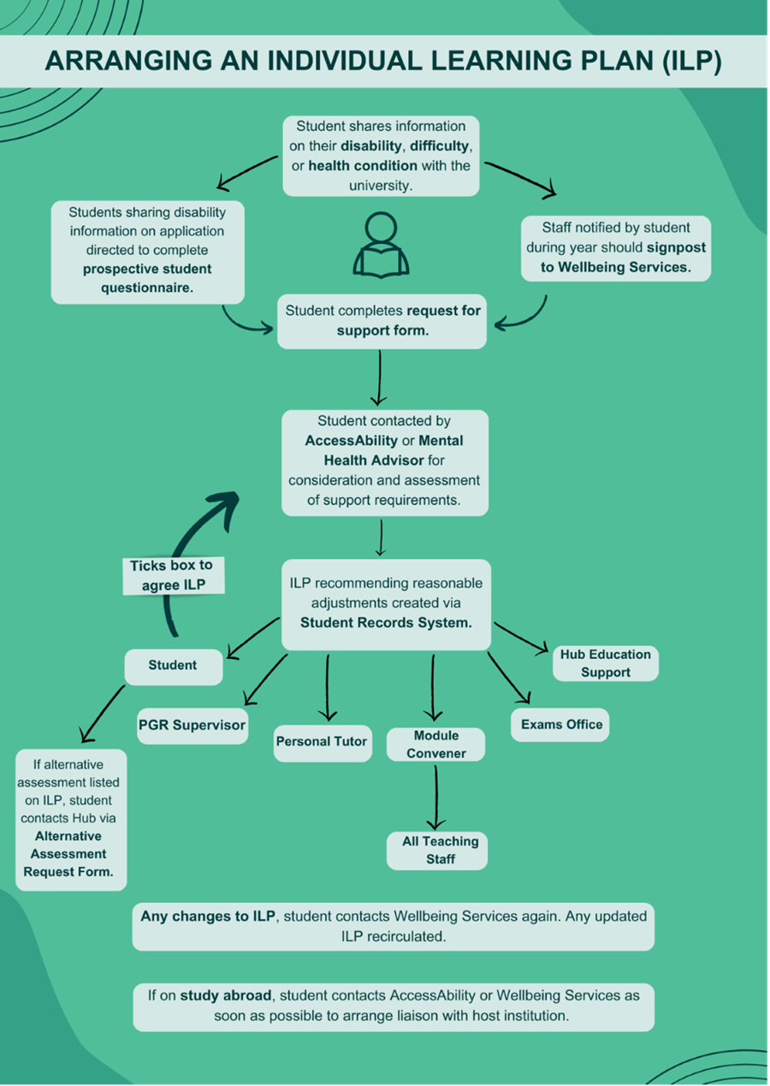

Creating accessible content
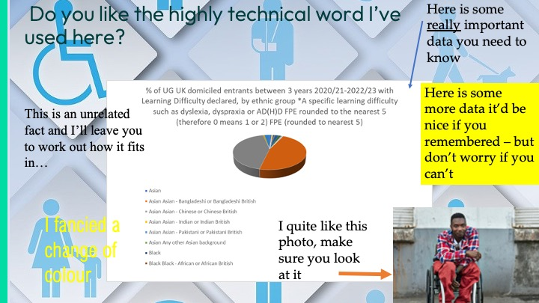
When delivering lectures, slides can be useful tools to both identify and illustrate your key points. However, without accessibility considerations, some students will face significant barriers to their learning. This example slide is inaccessible to many disabled students: it is cluttered, has no logical flow for students to follow, it uses poor colour contrast, and key information is inaccessible to a screen reader.
Creating slides with some simple points in mind will help all your students follow your lecture and access your content.
Read the infographic below for some top tips on creating accessible lecture slides
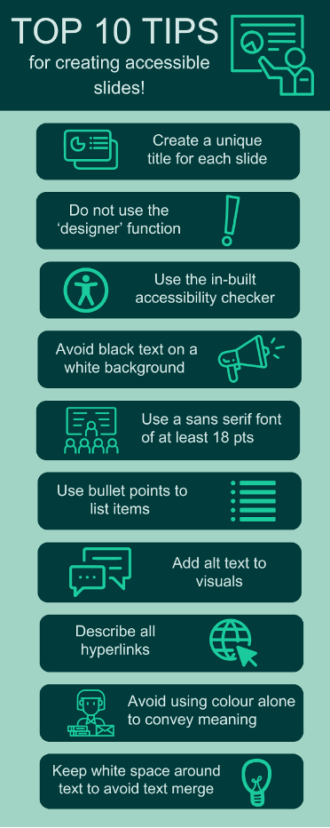
Please visit this SharePoint page for more information on creating accessible lecture slides, and a case study from Dr Edward Mills, Postdoctoral Research Fellow



Supporting Neurodivergent PGRs, their supervisors and their examiners
To address the challenge of support for neurodivergent PGRs, we have initiated a collaborative effort with the Doctoral College and the Accessibility Team. Together, we are developing a comprehensive series of targeted online resources tailored to assist PGR supervisors and examiners in effectively supporting neurodivergent PGRs throughout various stages of their academic journey, including supervision, upgrades, and VIVA examinations. Furthermore, as part of this project, we are actively involving our PGR community in creating resources specifically designed to meet their unique needs. By incorporating their insights and experiences, we aim to ensure that our support mechanisms are truly inclusive and responsive to the diverse requirements of our PGR cohort. This project represents a significant expansion of our vision to ensure our doctoral supervisors are equipped with the knowledge and skills they need to support the success of all PGRs.
If you have any questions about supporting neurodivergent PGRs, please contact the Educator Development team at eduexe@exeter.ac.uk.

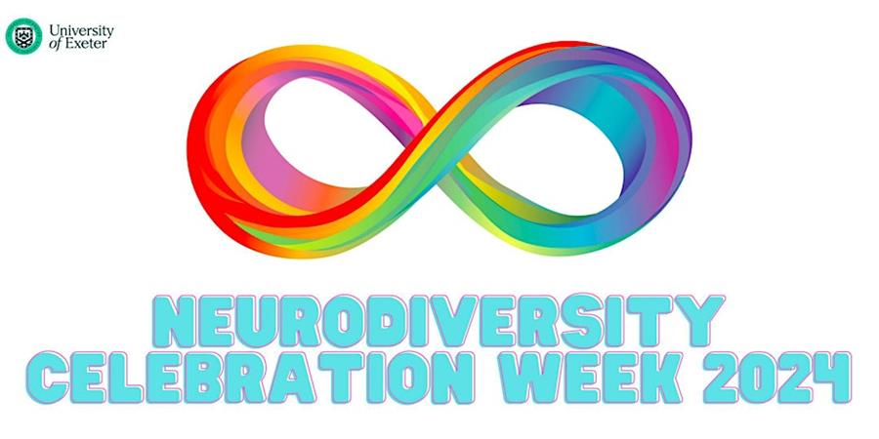

Feedback from Neurodiversity Celebration Week
Great initiative! I learnt so much from these very interesting talks
Useful to raise awareness of dyspraxia and how it affects the way a dyspraxic person's brain works rather than just writing it off as physical clumsiness.
An extremely welcoming, insightful and inspiring array of events - would recommend to everyone!
Exeter acts as a pinnacle for what all neurodivergence should be, open conversations and act as a vanguard in changing the knowledge of neurodivergence for the better.



Existing case studies and resources
The following EduExe Toolkit pages provide for resourcessupporting disabled students:
- Inclusivity Hub
- Accessibility Hub
- Supporting Autistic Students
You can also access the following case studies of inclusive practice from around the university:
- Supporting Students with ILPs in Physics and Astronomy (sharepoint.com)
- Neurodiversity in Higher Education - Psychology (sharepoint.com)
- Using plain English (sharepoint.com)
- EduExe blog Preparing students for assessment in Mathematics and Statistics
- EduExe blog Co-designing marking criteria with students for non-standard assessments

Have you found these helpful? Watch this space!
The Educator Development and AccessAbility team are working on a new landing page for all things disability and inclusive education. It will include information about the Equality Act and what ILPs are for, different types of disabilities and associated learning needs, where and when to signpost, what different reasonable adjustments mean, and practical tips for teaching and learning practice. Once complete, this will be rolled out to all university staff in the form of SharePoint pages. In the meantime, please visit the various links and resources included in this newsletter or if you would like any specific resources to support your teaching and learning, please contact Rachel Griffiths (r.griffiths@exeter.ac.uk).



Professional development teaching in sustainability survey
We are running a short survey to help us understand how confident our educators feel in teaching about sustainability. We are using the results of this survey to inform our development and support practices and to ensure educators get the support they need in teaching about these topics. It should take you 5-10 minutes to fill it out, depending on how much you would like to say.
Complete the survey



Students as change agents call
The Student Experience Partnership Board (SEPB) has provided funding to support Students as Change Agents (SACA) projects during 2023/24. We have been recruiting student-led proposals over the last few months and these projects are now getting underway. In addition to the ‘bottom-up’ projects, we agreed to support some ‘top-down’ student internships to support student change projects. We ran several of these projects during the summer of last year with great success. We are now welcoming bids from projects exploring a strategic priority for the University to gain student-led insight or co-created development to improve a specific area of the student experience. We are particularly keen to explore the following themes, which you can read about more on our website:
- Promoting student community and engagement
- Improving Academic Support
- Student Communication Approaches
We particularly welcome projects that explore a theme on a university-wide basis, but more focused projects that can demonstrate impact for a wide group of students and potentially have broader applications to other areas of the university are welcome. Each approved project will receive 219x hours to be worked on by one or two students. Students will be employed through the Student Campus Partnership scheme on Tier 2 at £13.65 per hour. Therefore, the total cost per project is £2989.35, plus a management fee of £100 per intern appointed. We are looking to award four projects in this round.
This equates to 6x weeks’ full-time work for 1x intern or 3x weeks’ full-time work for 2x interns. Any projects sponsored, and therefore hours claimed by interns, must be completed in the seven-week window between Monday, 10 June and Friday, 26 July 2024.
We are now seeking proposals and ask colleagues to send us an outline of your project idea, answering our short online form. This form will close at 12 noon on Friday 26 April. After successful projects have been chosen, we will recruit student interns through a single advert, using your project proposals to draw interest. We aim to have all interns ready to begin work on projects from Monday 10th June. The named staff member leading on successful projects will be responsible for coordinating the work of their assigned student interns, and approving pay claims as necessary.
If you have any questions, please contact changeagents@exeter.ac.uk



THE Campus call for contributions
Through our partnership with THE Campus, we receive regular calls for content, as well as a rolling call for contributions on THE Campus key topics. The current calls for content are on:
How do universities work? Practical advice and insight from and for HE professionals on:
- What does a vice-chancellor/provost do in your country?
- How to write/read a university budget (in 800 words)
- What is a university senate and how does it work?
- How are public universities different from private ones?
- How does research funding work?
- How does university recruitment work?
- The changing role of the university in society
- Structures/hierarchies in a university explained
- An overview of roles and departments
Deadline for content: Monday, 22 April
Indigenous voices in higher education Practical advice from and for HE professionals on:
- How to integrate Indigenous knowledge into curricula
- Insights and lessons from Indigenous-serving institutions
- Case studies from Indigenous centres on campuses
- How to support and retain more Indigenous students in higher education
- How to recruit and promote more Indigenous staff in universities
- Involving Indigenous communities in research
- Amplifying Indigenous voices and scholarship
Deadline for content: Monday, 6 May
Tackling the PhD thesis Practical advice and insight from and for HE professionals on:
- Writing tips
- Time management
- How to structure your thesis
- How to write a thesis/dissertation in three months
- How to write an abstract
- What to do after it’s finished
- Understanding the PhD thesis in your country
- How to prepare for a viva voce or doctoral defence of your thesis
- What to do when motivation flags
- Tips for managing referencing and bibliography
Deadline for content: Monday, 20 May
If you are interested in contributing to THE Campus, please contact eduexe@exeter.ac.uk with your pitch and download the Campus editorial guidelines.
Send your pitch to the EduExe team!

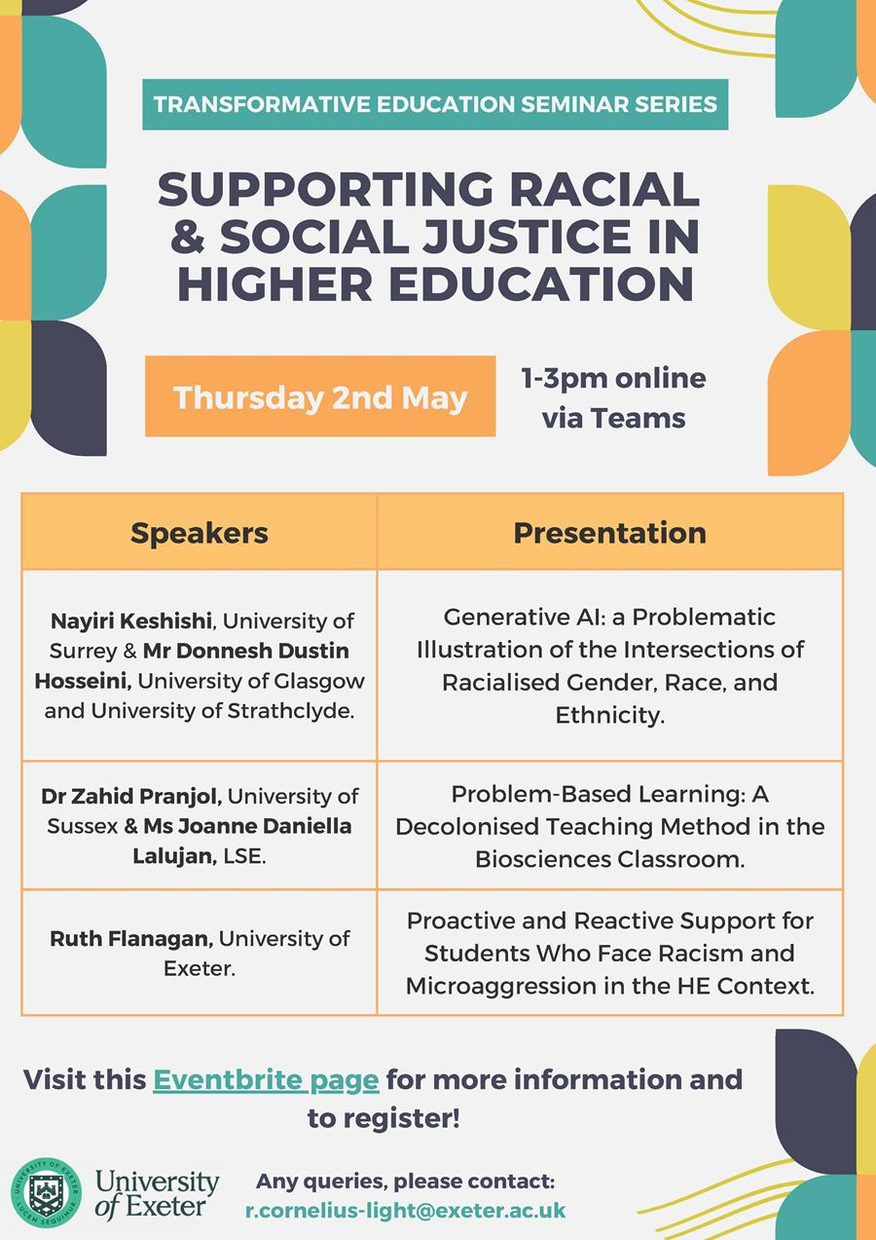

Upcoming events
- The ninth seminar in the Transformative Education Seminar Series is titled ‘Supporting Racial & Social Justice in Higher Education’ and will take place on Thursday 2nd May 13:00-15:00 via MS Teams. This seminar will be led by Professor Vrinda Nayak, Associate Dean for Taught Students (Racial Equality and Inclusion) and speakers include Nayiri Keshishi (University of Surrey), Mr Donnesh Dustin Hosseini (University of Glasgow & University of Strathclyde), Dr Zahid Pranjol (University of Sussex), Ms Joanne Daniella Lalujan (LSE), and Ruth Flanagan (University of Exeter). Please visit our Virtual Poster for more information and our Eventbrite Page to sign up!
- ‘Our Neurodivergent Experience’ - this exhibition, supported by University of Exeter’s Engaged Public Research fund, empowers marginalised neurodivergent young people in Devon. Through collaborative efforts with local community interest groups and creative professionals, it provides a platform for challenging stereotypes and amplifying diverse voices. Members of University of Exeter’s Student Guild and NDSS will contribute their own voices and experiences. This is both an online and physical art exhibition, with the latter being available to view at Positive Lights Projects, Sidwell Street, Exeter at the end of June. Please visit this page for more information.
- STEAM Education: Progressing from Primary through to Tertiary - Join us to explore how STEAM education evolves throughout formal education levels, with dialogue and insights from cutting-edge research on 22nd May, 4.30-7pm in the Forum. Book your place through EventBrite.



On EduExe socials this month
EduExe continues to grow our social media presence, sharing updates, best practice and discussing current issues in Higher Education.
If you are interested in contributing a case study of your practice to the EduExe blog, please contact us on eduexe@exeter.ac.uk!
Don't forget you can follow us on LinkedIn for updates!
Read the EduExe blog

EduExe Only Connect - The Answer!
Last month's EduExe challenge is our very own Only Connect wall! Here is the completed wall:
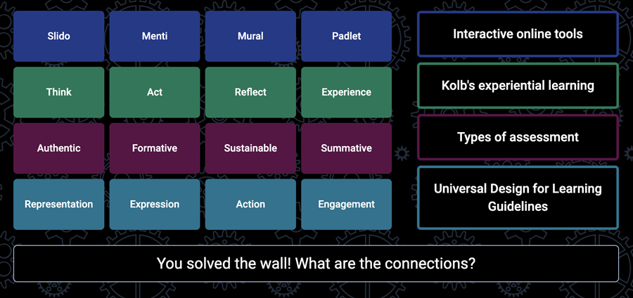

April Challenge - The EduExe Cryptogram!
This month we have created a custom cryptogram.
Each letter in the phrase has been replaced with a random letter or number – try to decode the message to discover a neurodivergent difference being celebrated in June’s online exhibition.
Send you completed cryptopgram to eduexe@exeter.ac.uk.
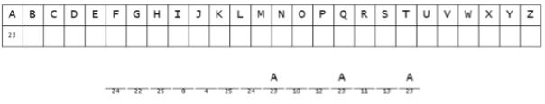

Interested in contributing to the newsletter?
We will have rolling deadlines for submissions each month, so please get in touch with eduexe@exeter.ac.uk if you would like to contribute!
We want your feedback!
The EduExe newsletter is a new initiative, and we would love to hear from you if you have any feedback! You can share it with us anonymously on our feedback form or by email to eduexe@exeter.ac.uk.

Follow us on social media or visit our website to find out more about educator development and enhancement at Exeter!


Join the EduExe teams site to connect with educators across the University

