Welcome to the first EduExe newsletter!

The EduExe Newsletter is a new initiative for all colleagues involved in education, focusing on on news, updates and all things educator development and enhancement. This monthly newsletter will include relevant articles and resources according to the time of the academic year, updates on strategic projects, reminders of key deadlines (i.e. for module amendments) and much more!
In this issue, we have articles and resources on:
- An update on generative AI - a message from Professor Tim Quine
- Transitions - supporting new students
- Signposting your students
- Academic personal tutoring
- Students supporting students – Peer Support
- Learning and Teaching in Higher Education Programme
- New Transformative Education Framework Curriculum Enhancement Toolkit
- New LGBTQ+ Toolkit
- Education Incubator Discovery Grants open for applications
- Relaunch of the EduExe Blog
- Upcoming events
- The EduExe Crossword - with prizes!



An update on generative AI - a message from Professor Tim Quine
At the start of the new academic year I want to remind you of policies, resources and support in relation to generative AI which will continue to be a key feature of the education landscape.
Policies and useful links
If you have not already done so, I suggest you download our Institutional Statement on Generative AI, which sets out our commitment to ethical and responsible use of AI tools in our education practices. You may find it useful to read and refer to:
- The Department for Education’s ‘Generative AI in education’ statement
- The Russell Group’s ‘New principles on use of AI in education’
Academic Integrity
An important element of our approach to using generative AI in teaching, learning and assessment is ensuring academic integrity. To do this, we have amended the list of Academic Misconduct Offences in Chapter 12 of the Assessment, Progression and Awarding: Taught Programmes Handbook on Managing Academic Conduct and Practice . This section of the University’s Teaching Quality Assurance (TQA) Manual makes it clear that the use of text or ideas obtained from an AI tool should be acknowledged in the same way as those taken from human authors. An additional offence of ‘Contract Cheating’ has been added to those listed in 12.3. This will cover scenarios where students have purposefully set out to solicit a third-party contribution and then present it entirely as their own. Contract cheating will include work obtained from AI sources.
We also introduced a pre-misconduct process viva, for colleagues to use where there is a suspicion of misconduct using generative AI, but without enough concrete evidence to be referred in to the academic misconduct process.
To support colleagues, Academic Development and Student Cases have developed a generative AI and academic misconduct list of Do’s and Don’ts.
We are also in the process of piloting the Turnitin AI detection tool, and plan to update you on our progress soon.
Resources and support
To support colleagues getting to grips with generative AI and its impact on education, the Academic Development team have developed the following resources:
- New AI Hub on the Education Toolkit
- A new AI and Assessment matrix
- A tool for reflecting on assessment in light of AI (to be launched on the AI hub later this week!)
If you would like to talk to a member of the Academic Development team about the training and support we can offer in your Faculty/Department or for advice on enhancing your teaching and assessment practice, you can email eduexe@exeter.ac.uk or book an appointment with a member of the team online.
As we continue to develop our policy and practice around generative AI, we are interested in guidance and support being developed at local level and developing a bank of best practice on the AI Hub. Please do share anything you have developed with us at eduexe@exeter.ac.uk!



Transitions - supporting new students
Transition to university can fundamentally change numerous aspects of students' lives. A major change is the transition from teacher-led classroom learning to self-directed learning, new teaching styles and fewer contact hours.
What can I do to support students with their transition to university?
- Set clear expectations. Don't presume that students know what you mean when you set what might appear to be an obvious task, such as 'Read this article'. Be explicit in how you would like them to approach this task: 'Read through this article, making brief notes on at least four key points relating to xxx'.
- Don't assume prior knowledge. Be aware that all students will have had different learning experiences in your subject, and in their approach to study. Include activities that allow all students to participate, regardless of prior knowledge, and encourage them to share what they know already and where their gaps are. This way, they will soon see that they aren't the 'odd one out' if there are topics that they struggle with.
- Remind students that it's ok to ask for support. Be open, approachable, and mindful that students may experience challenges with transition at different times during the academic year, so try and check in with them throughout the terms.
- Signpost students to the relevant teams, services and resources that will help them. Don't presume that they are familiar with these, and think about different ways to signpost (verbally, via email, in Teams etc.) so that students are more likely to connect with the relevant service or resource.
Access our Transitions Hub on the Education Toolkit for more advice and students experiences of transitioning to university.



Signposting your students
Here are some key services and resources to signpost your students to:
- Study Zone and Study Zone Digital
- Wellbeing Services and AccessAbility
- Digital Hub
- Library Induction and 1:1 support
- Guild Advice Unit
- International Student Support



Academic personal tutoring
Welcome back to another academic year supporting our students to achieve their potential. As always we are here to support you, providing training and resources to help ensure that you can manage your tutor role and enjoy it. Although there can be challenges, being a tutor can also be the most rewarding part of your year.
For new tutors there is a Developing your practice road map to help you to get started. Here we have selected key resources and information to get you set up in your tutoring role at Exeter. All our tutoring resources are now housed in the Education Toolkit – so easy for you to find, and to share with colleagues. You can find help with activating your digital tutoring space, links to support referral, session plans for group tutorial and much more.
This year there are even more workshops available. This year you can book:
- Introduction to Personal Tutoring
- Managing Expectations and Maintaining Boundaries
- Effective Record Keeping for Tutors
- Senior Tutor Induction
- Tutoring International Students
- Evaluating your tutoring practice
- Belonging and Mattering
- Tutoring your PGTs
Coming soon will be another new workshop – Welfare and Wellbeing for tutors. As in previous years, if you would like a workshop, or series of events, planned for your discipline, these can be designed and delivered, just drop us a line at eduexe@exeter.ac.uk.
The Mental Health and Suicide Awareness Level 1 and Mental Health and Suicide Safety Level 2 training are highly relevant to tutors.
Take a look at the wealth of resources on Academic Personal Tutoring on the Education Toolkit



Students supporting students – Peer Support
Who are we? The Peer Support team coordinates a range of pastoral and academic peer support progr﻿ammes, which match 1st year students with students in higher years with similar backgrounds.
But more than that - we connect students with each other, creating social and learning communities.
We run a number of pre-arrival schemes within the team itself, including:
- Care Leaver and Estranged Student Peer Mentoring
- Disabled Student Peer Mentoring
- Mature Student Peer Mentoring
Our ultimate aim is to help students help students to become independent members of the University community.
If you have any questions about our work or know students who would like to be involved, get in touch at peersupport@exeter.ac.uk.
Don't just take our word for it – see what Mentors like Leo have to say.



Learning and Teaching in Higher Education Programme
A new academic year brings fresh opportunities to try new things in our teaching and to continue developing our practice as educators. For staff who may be taking some of their first steps in teaching and supporting learning at the university, LTHE offers a grounding in a range of teaching essentials, including:
- Developing student-centred, inclusive and constructively aligned teaching sessions
- Assessment, marking and feedback practice
- Reflective practice and developing your identity and values as an educator
Who is LTHE for?
The programme is designed to provide early-career developmental support for:
- Doctoral students undertaking work as postgraduate teaching associates (PTAs)
- Postdoctoral researchers with limited teaching responsibilities
- University associates who teach or support learning
- Professional Services staff who teach or support learning
How is LTHE structured?
LTHE is made up of five short taught units, which are designed to be completed over the course of an academic term. An optional sixth unit is also available for those who wish to complete the LTHE assessment, which offers a pathway to AFHEA status and 30 credits at Level 7. It is intended to be a fun, active and practical course, with the chance to learn from, and collaborate with colleagues from across the university.
When and where is LTHE running?
The 2023/24 programme is running on-campus in the Autumn and Spring terms, with intakes at both our Streatham and Penryn campuses. We will also be running an online-only route for participants over summer 2024. Although our Autumn 2023 programme is already fully subscribed, expressions of interest are formally open for our Spring 2024 intake.
For more information about the LTHE programme, please visit our dedicated SharePoint site.
Interested in how to support PTAs at departmental level? Read this case study from Classics and Ancient History about the support they provide to PTAs on marking and assessment

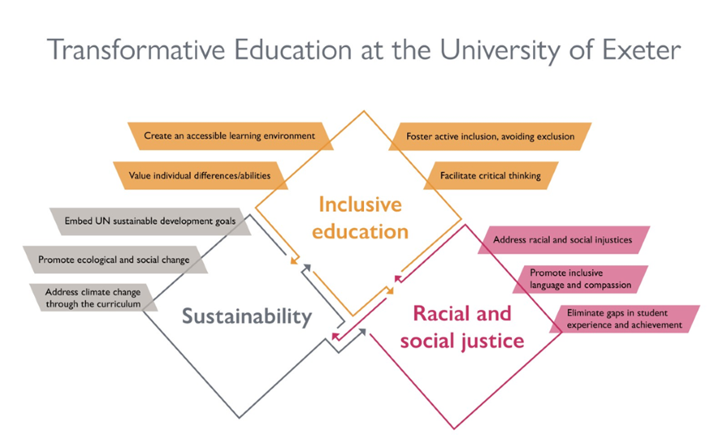

NEW Transformative Education Framework Curriculum Enhancement Toolkit
The TrEF Curriculum Enhancement Toolkit serves as a guidance tool aimed at assisting educators in incorporating the principles of the Transformative Education Framework into their curriculum content. This initiative is part of Strategy 2030 effort to harness the transformative potential of education and research to foster a sustainable, equitable, and healthy future. This toolkit primarily focuses on aiding the development of the arguments, concepts, perspectives, evidence, and voices that constitute the core content of modules and programs. It specifically addresses the intertwined concepts of inclusive education, racial and social justice, and education for sustainable development. We extend an invitation to educators to explore and use this resource as part of their module design process, and welcome feedback and the submission of case studies to keep improving the guidance we offer and to celebrate the work being done within the university.
Access the TrEF Curriculum Enhancement Toolkit



NEW LGBTQ+ Toolkit
We are excited to introduce our new LGBTQ+ Toolkit to support educators in addressing gender and sexuality within learning environments. This resource is specifically designed to help educators create inclusive and supportive classrooms for LGBTQ+ students at Exeter, incorporating valuable insights from students and staff. This comprehensive guidance addresses key areas and essential topics like understanding LGBTQ+ terminology, pronoun usage, titles, and collective terms to ensure respectful communication. Furthermore, the guidance refers to strategies for encouraging student engagement, such as amplifying queer voices, understanding emotional labour, and promoting diverse representation in your curriculum content. Our guidance also equips you to address discrimination head-on, alongside specific insights on the use of content warnings and reporting tools, helping to design a compassionate learning environment. Frequently asked questions and additional resources are also provided, allowing you to deepen your understanding and support for LGBTQ+ students.
Access the LGBTQ+ toolkit



Exeter Education Incubator Discovery Grants 23-24 are now open for applications!
The Exeter Education Incubator cultivates pedagogic innovation and collaboration by providing grants for University of Exeter academic and professional service staff to work on an identified pedagogical challenge.
Our Incubator Discovery Grants are funds of up to £300 for educators who want to understand a teaching and learning challenge and test possible solutions within their faculty. We will award five Incubator Discovery Grants per faculty and awards will be made in conjunction with Faculty Associate Pro-Vice Chancellor Education.
This grant is aligned to Design Thinking, and the grant must be used to complete two of three Design Thinking templates, which you can access here:
- Empathy Map
- Systems Map
- Proto-type Evaluation
These tools will enable educators to plan activities, gather diverse perspectives and experiences related to your pedagogical challenge to help explore the idea further.
There is a light touch application form and the deadline for applications is Friday 13th October 2023.
For more detailed information on the open call and how to access the application form please read here: Incubator Discovery Grants.
If you have any questions about the Discovery Grants or the Design Thinking problem-solving templates before you apply, please contact us via educationincubator@exeter.ac.uk.



Relaunch of the EduExe blog
We are relaunching the Excellence in Education blog as EduExe! The EduExe blog will be a hub of case studies of good practice at the University of Exeter – so we can share these internally, but also externally with the sector to promote our education practice. For the relaunch we are celebrating some of our award-winning educators from the past year with case studies of their award-winning practice, including:
- Grand Challenges team – winners of a Collaborative Award for Teaching Excellence from AdvanceHE
If you are interested in contributing to the EduExe blog, please email eduexe@exeter.ac.uk with information about your case study!
Read the EduExe blog

Upcoming events

Fostering belonging - The role of teaching practices in STEM
27th of September, 9:30 – 12:00
Register on EventBrite
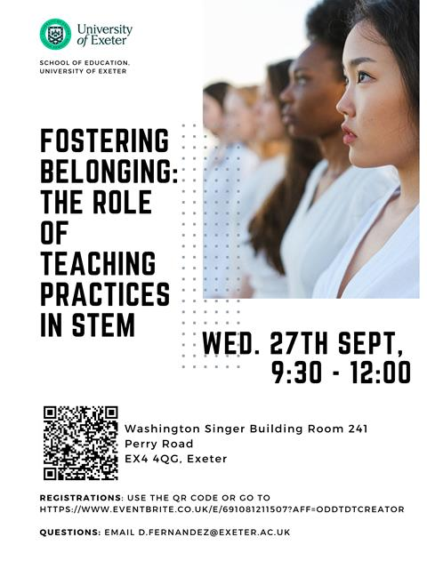
How does the way students learn about sciences relate to their sense of belong to their discipline? Which teaching practices are perceived by students from underrepresented groups as drivers for their sense of belonging? How can we promote students’ sense of belonging in STEM?
In this event, we will share the results of our survey "Made to measure?", where we asked University of Exeter students from Science, Technology, Engineering and Maths (STEM) disciplines about the teaching practices that help them (and don’t help them) to feel they belong in their programmes.
The event is open for academic staff, executive members, and those involved in ED&I policy and practice, and improving inclusion and diversity culture.



The EduExe Crossword
For a bit of fun, we've created our own crossword! Why not give it a go? Answers in next months' newsletter...Anyone who submits a copy of they're completed crossword will win an EduExe coffee mug!
You can also download a word version of the crossword.

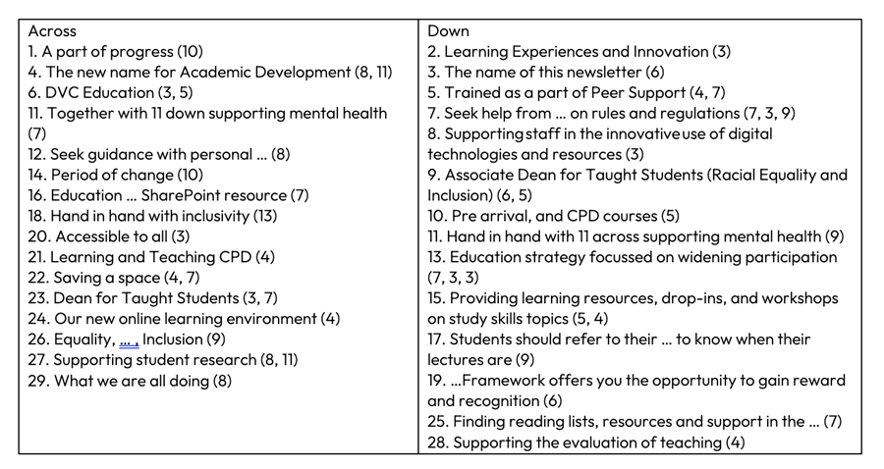

Interested in contributing to the newsletter?
We will have rolling deadlines for submissions each month, so please get in touch with eduexe@exeter.ac.uk if you would like to contribute!
We want your feedback!
The EduExe newsletter is a new initiative, and we would love to hear from you if you have any feedback! You can share it with us anonymously on our feedback form or by email to eduexe@exeter.ac.uk.

Follow us on social media or visit our website to find out more about educator development and enhancement at Exeter!

