Welcome to the May EduExe newsletter!

The EduExe newsletter is an initiative for all colleagues involved in education, focusing on news, updates and all things educator development and enhancement. This monthly newsletter will include relevant articles and resources according to the time of the academic year, updates on strategic projects, reminders of key deadlines (i.e. for module amendments) and much more!
If you experience any accessibility issues with this email, you can download a word version on the Educator Development website
This issue we have updates, articles and resources on:
- Launching the EduExe Festival 2024
- Useful links and resources on the Transformative Education Framework
- Authentic Assessment: How the Learning Design Team can support your journey
- Marking and feedback resources reminder
- Curriculum for Change and Student Academic Support SharePoint sites
- ASPIRE Framework to be relaunched as EduExe Framework in September 2024
- HESA reporting - keep your record up to date!
- QS ImpACT Skills Challenge
- THE Campus call for contributions
- On EduExe socials this month
- The EduExe Cryptogram - The Answer!
- May photo challenge

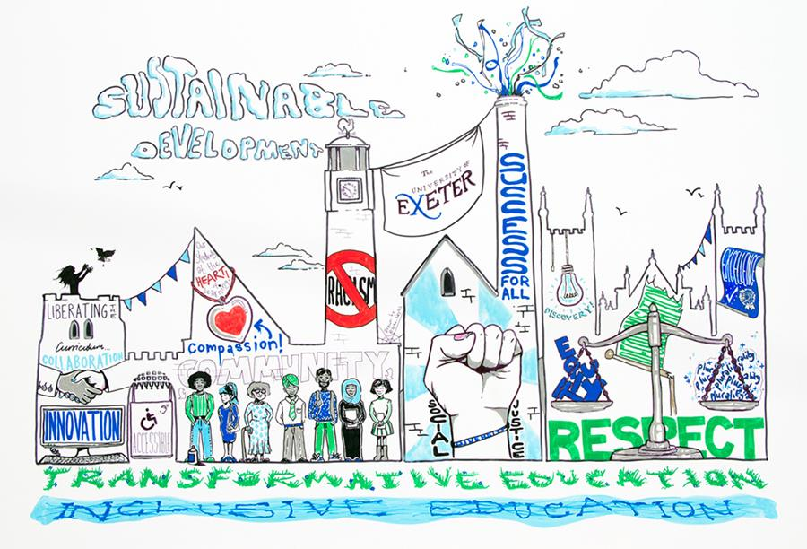

Launching the EduExe Festival 2024
Following the success of the EduExe Festival 2023, we will be running a two-week festival in 2024 with the theme ‘Future Positive’ – celebrating all the excellent work we have done so far under the Transformative Education Framework and looking forward to Curriculum for Change.
The EduExe Festival 2024 will take place online from 17th-28th June 2024, and will include contributions from across the sector on the following themes:
- Decolonising education
- Inclusive education
- Racial and social justice in the curriculum and in the classroom
- Sustainability and the UN SDGs in the curriculum
- Tackling grand challenges and ‘wicked problems’
- Developing ‘Future Positive’ skills
The format of events may include workshops, lectures/talks, discussion panels, hackathons, drop ins and much much more! Where appropriate, events will be recorded and turned into episodes for the EduExe podcast.
Any questions, please contact eduexe@exeter.ac.uk.
Submit your proposal
Visit the EduExe Festival website

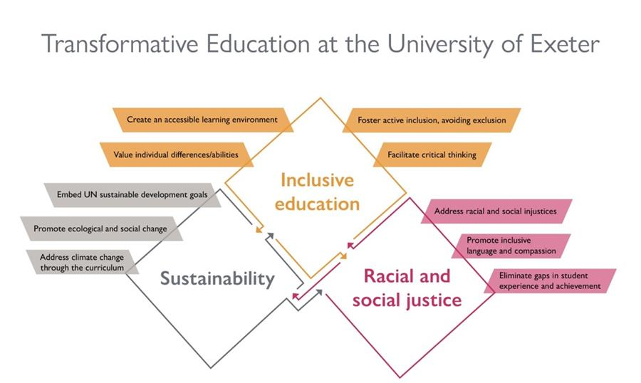

Useful links and resources on the Transformative Education Framework
To find out more about the Transformative Education Framework (TrEF), and access resources on how to incorporate it in to your teaching, you can visit the following SharePoint sites:
- Transformative Education Home
- Transformative Education Events and Seminars
- Decolonising Sustainability
- Education for Sustainable Development (ESD)
- Transformative Education Framework Curriculum Enhancement Guide
- Supporting LGBTQ+ Students
- Supporting Racial & Social Justice in Higher Education
- Decolonisation at Exeter Toolkit
- Degree Awarding Gaps Resources



Authentic Assessment: How the Learning Design Team can support your journey
With GenAI moving from the novel to the everyday and the renewed focus on Universal Design for Learning (UDL), the importance of Authentic Assessment is clear. Authentic assessment aligns closely with real-world experiences, ensuring that the tasks and projects students undertake are not only relevant to them but also directly applicable to their future careers and personal growth. This approach to assessment is crucial for fostering inclusivity, as it considers diverse learning styles and backgrounds, allowing each student to engage with the material in a meaningful way. Additionally, by focusing on real-life challenges, authentic assessments boost student engagement and make learning more relevant to their future goals.
The Learning Design team would like to offer our support to individuals and teams to adapt and create authentic assessments that embody these principles. We can provide guidance on how changes can be made without having to revisit your PAAF or module descriptor.
Key tips for supporting Authentic Assessment
- Involve students in the assessment process
Involving students in the creation and refinement of assessments can lead to more personalised learning experiences and greater investment in the outcome of their educational journeys. This participatory approach can take many forms, from students helping to define assessment criteria to choosing the format of their projects. By giving students a voice, educators can ensure assessments are not only fair but also deeply engaging.
2. Provide formative assessment opportunities and scaffolding
Throughout your module/programme, provide formative assessment opportunities so that students can see improvement over time as well as taking clear steps towards their final assessment. Students can also get involved in assessing themselves or their peers to help foster even deeper learning and understanding.
An assessment should be holistic and not appear as an addition at the end of learning.
3. Ensure assessments hold future relevance
To prepare students for the complexities of the real world, assessments should mirror the tasks they are likely to encounter in their professional lives. This approach not only validates the learning process but also equips students with the skills and confidence to tackle similar challenges post-graduation.
4. Focus on a context and a task.
Creating a context for your assessment based on real-world situations will help you envision authentic tasks for students to work on as part of that context. Through this method you should be able to create an authentic assessment for your students.
How can we help?
We can help by working collaboratively with you 1-1 or via a workshop to redesign existing assessment or co-create new authentic ways to assess your students.
Please get in touch with Learningdesign@exeter.ac.uk for more information.
How we designed an authentic assessment for online learners in educational psychology



Marking and feedback resources reminder
As we move in to the term 3 exam period, we wanted to take the oppurtunity to remind you of the EduExe Toolkit and 5 days of feedback resources on marking and feedback.
EduExe Newsletter November special issue on feedback
Five days of feedback round up in December 2023 newsletter
EduExe Toolkit - Assessment and Feedback

Curriculum for Change and Student Academic Support SharePoint sites
Two strategic projects have launched SharePoint sites this week within the Pilot and Scaling portfolio that sits within Learning Experiences and Innovation (LXI)

Curriculum for Change (C4C) SharePoint site and upcoming events:
C4C is working in partnership with faculties and departments to consider how we realise our strategic commitment to develop a distinctive and sustainable model for education. To find out more, we encourage you to visit the recently launched Curriculum for Change SharePoint. From this SharePoint, you can register for monthly C4C staff drop-in events to receive updates on C4C activities, ask any questions you might have, and provide your input into emerging proposals at an early stage. Next month’s sessions will focus on alternative models for the academic year (20 and 23 May) - Please do sign up and get involved. If you have any questions for the project team, these can be directed to curriculumforchange@exeter.ac.uk
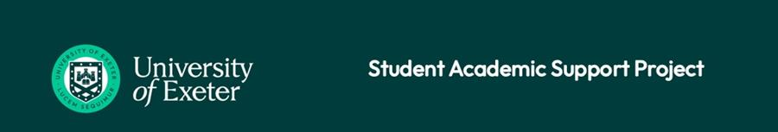
Student Academic Support (SAS) Project SharePoint site:
The SAS project team has been working closely with each faculty and department to roll out a new model for Student Academic Support. The SAS project is focused on the implementation of changes to practice, including the introduction of Pastoral Mentors in departments, that can improve and reduce the variability of each student’s experience of academic support, and improve outcomes for all students. To find out more about this project, including the plan for the phased rollout to departments by September 2025, we encourage you to visit our Student Academic Support SharePoint and our webpage.

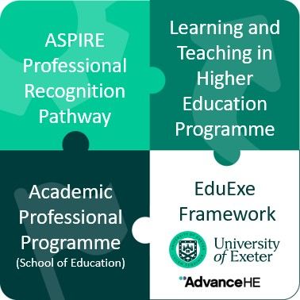

ASPIRE Framework to be relaunced as EduExe Framework in September 2024
As part of the reaccreditation process, we will be relaunching the ASPIRE Framework in September 2024 as the EduExe Framework. The relaunch marks a number of changes:
- The move to PSF 2023, which includes updated dimensions of practice and different requirements for categories of fellowship (i.e. Fellow, Senior Fellow)
- A desire to distinguish between the ASPIRE Professional Recognition Pathway and the Framework, whilst giving the Framework a distinctly 'Exeter' identity
To prepare colleagues for the relaunch and the move to PSF 2023, we have created a SharePoint site outlining the move to PSF 2023, key changes and when you can start applying under the new framework. Please note that we will not be moving to PSF 2023 until September 2024, and current applicants should continue to apply under UKPSF 2011.
Find out more about PSF 2023



HESA reporting - keep your record up to date!
We have an annual check of our HESA data coming shortly in June, in collaboration with Advance HE. We want to ensure that the University’s HESA return is as accurate as possible, and that colleagues have all their achievements correctly recorded. Please take a few minutes to do the following before the end of May:
- Make sure that your HESA data on Trent is up to date. Go to ‘View Profile’ – click on ‘Employment’ in the top bar – in ‘Additional employment information’ you will see a link to update your qualifications and awards.
- If you have an Advance HE award, you will have an online account with them, which includes any Advance HE / HEA certificates awarded. Please download a copy of this guide and make sure that your record is kept up to date. MaintainingYourMyAdvanceHEAccount.pdf (advance-he.ac.uk) . If awarded via the ASPIRE framework, you will have received an email from Advance HE with a link to your certificate. Recent achievers may not yet have an Advance HE profile – the award has to go through a verification process first. If there are any issues with your Advance HE account, the Guide includes instructions for making contact with Advance HE to raise a query.


Have you heard of the Skills Challenge running this summer? It’s a new program that QS ImpACT is organising for students around the world.
The Skills Challenge is a sustainability-focused game design challenge for students. The event challenges students to participate a design a game that maps the UN Sustainable Development Goals around their campus or community.
The aim is to help students upskill through game-design technology and collaborative teamwork, and also empower and educate their communities and campuses on sustainable development.
We would be grategul if you could disseminate this information to your students and encourage them to make teams (between 3-5 people per team).
We look forward to having some student teams from The University of Exeter.
To learn more about the challenge, please see the website here: SKILLS CHALLENGE – QS ImpACT News



THE Campus call for contributions
Through our partnership with THE Campus, we receive regular calls for content, as well as a rolling call for contributions on THE Campus key topics. The current calls for content are on:
Tackling the PhD thesis Practical advice and insight from and for HE professionals on:
- Writing tips
- Time management
- How to structure your thesis
- How to write a thesis/dissertation in three months
- How to write an abstract
- What to do after it’s finished
- Understanding the PhD thesis in your country
- How to prepare for a viva voce or doctoral defence of your thesis
- What to do when motivation flags
- Tips for managing referencing and bibliography
Deadline for content: Monday, 20 May
Ensuring students are workplace ready Practical advice from and for HE professionals on:
- Increasing employability in students
- How to integrate apprenticeships and degree apprenticeships with your institution and industry
- How to design microcredentials
- Advice for making credential wallets work
- How to teach students online and in-person interview skills
- Integrating emerging professional technologies like AI into the curriculum
- Preparing for jobs that don’t yet exist
- How to teach soft skills for the modern workplace
Deadline for content: Monday, 27 May
Should I become an administrator?
- Managing tensions with former faculty colleagues
- Being a good manager
- How to make the decision to switch from academic to administrator
- Should I become a dean?
- How to manage faculty relations
- How can faculty and administrators work better together?
Deadline for content: Monday, 3 June
If you are interested in contributing to THE Campus, please contact eduexe@exeter.ac.uk with your pitch and download the Campus editorial guidelines.
Send your pitch to the EduExe team!



On EduExe socials this month
EduExe continues to grow our social media presence, sharing updates, best practice and discussing current issues in Higher Education. New blog posts this month include:
- Playing learning and 'crime'
- Supporting students with public speaking anxiety
If you are interested in contributing a case study of your practice to the EduExe blog, please contact us on eduexe@exeter.ac.uk!
Don't forget you can follow us on LinkedIn for updates!
Read the EduExe blog

The EduExe Cryptogram - The Answer!
Last month's EduExe challenge was a cryptogram! Here is the answer:

Hyperphantasia



May Photo Challenge
To encourage you to get outside during the (hopefully) nice weather and busy marking period, we challenge our readers to go out on their campus and take a photo of an inspirational spot, email it to us and tell us why. We will share the submissions in the next newsletter!

Interested in contributing to the newsletter?
We will have rolling deadlines for submissions each month, so please get in touch with eduexe@exeter.ac.uk if you would like to contribute!
We want your feedback!
The EduExe newsletter is a new initiative, and we would love to hear from you if you have any feedback! You can share it with us anonymously on our feedback form or by email to eduexe@exeter.ac.uk.

Follow us on social media or visit our website to find out more about educator development and enhancement at Exeter!


Join the EduExe teams site to connect with educators across the University

