Welcome to the October EduExe newsletter!

The EduExe Newsletter is a new initiative for all colleagues involved in education, focusing on news, updates and all things educator development and enhancement at the University of Exeter!
We have to start by congraulating colleagues, once again, on the achievement of 'solid gold' for TEF 2023. The Office for Students (OfS) describes a Gold rating as recognising those universities "delivering consistently outstanding teaching, learning and outcomes for its students. It is of the highest quality found in the UK." This is of course down to our phenomenal educators - so thank you and congraulations.
This month is a special issue on formative assessment and feedback, with articles and resources on:
- In-class assessment for learning
- Top tips for formative assessment
- Sustainable assessment: assessment as learning
- Improving feedback with Turnitin Feedback Studio
To celebrate Black History Month, we also have a special feature on the ethnicity degree awarding gap (EDAG), and links to resources showing what you can do to help close the EDAG.
We also have the following updates and calls for contributions that may be of interest:
- Introducing the Educator Development team
- New resource - reimagining assessment reflective tool
- New resource - Freedom of Speech
- New EduExe teams site
- Global Exeter Innovation Fund now open!
- Latest THE Campus call
- QAA Collaborative Enhancement Project Call 2023-24
- Events happening this month
- EduExe socials this month
Finally, we have the answers to the EduExe Crossword, and a new challenge - the EduExe wordsearch



In-class assessment for learning

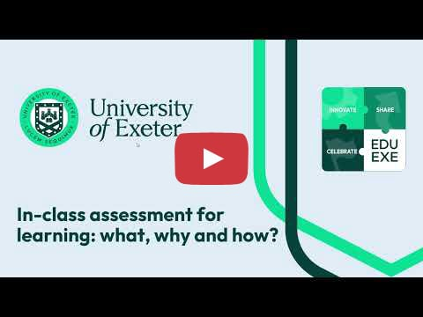
To find out more about in-class assessment for learning watch our video, check our infographic or download the video transcript!
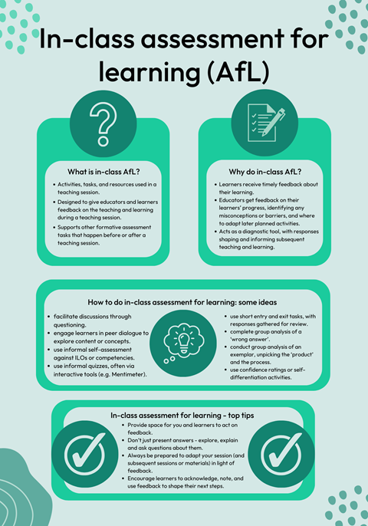

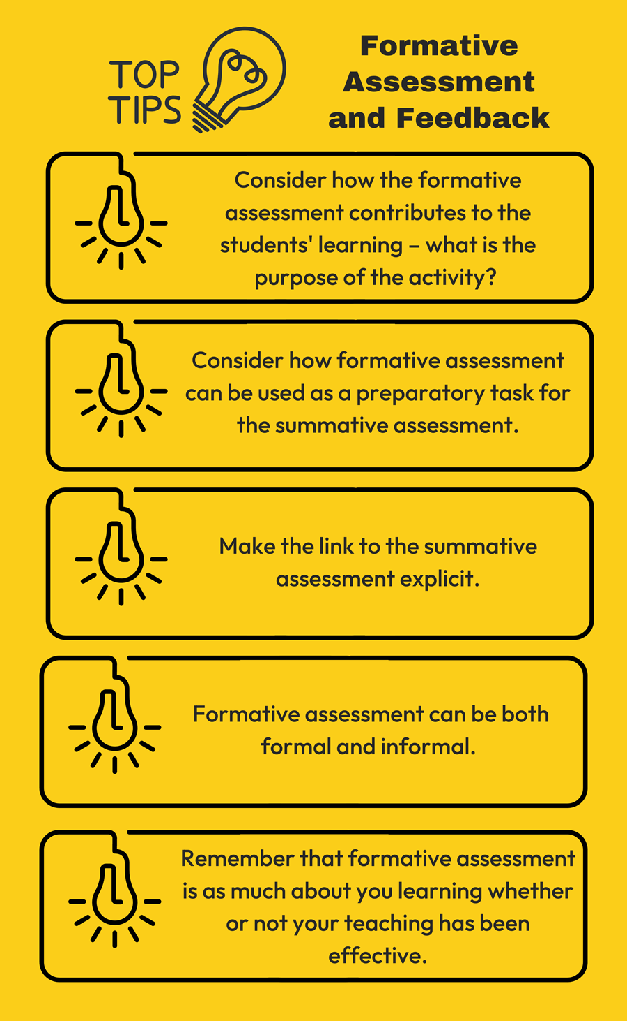



Sustainable assessment: assessment as learning
Sustainable assessment, a term explored most predominantly by David Boud, refers to assessment practices which enable learners to develop their ability to evaluate and make an informed judgement about a task or learning event. Sustainable assessment practice aims to support students not just with the assessment task at hand, but also to equip them with key skills for the world of work and their life beyond graduation.
Sustainable assessment focuses on embedding opportunities for students to reflect on and self-regulate their learning through assessment activities and tasks. Examples of how to do this include:
- Using peer-assessment and self-assessment, either informally in class, or as part of structured formal assessment tasks (formative or summative). Providing feedback to others helps students develop their assessment literacy, and highlights key aspects in the assessment task to focus on.
- Working with exemplar materials to make evaluative judgements against assessment briefs and marking criteria. Anonymous exemplars can support those students less confident to critique others’ work, and can scaffold an approach towards later peer- or self-assessment tasks. Make sure you ask permission from students before you use their work as an exemplar!
- Asking students to actively respond to feedback they have received in a subsequent assessment. Try and create space for feedback to ‘land’ (Pitt, 2020, p. 32) by embedding short reflective tasks where students engage with previous feedback and reflect on how they have responded to it. Encouraging them to create and use a feedback log will also help students see assessment as a learning process.
- Introducing two-stage assessment processes where students must iteratively develop their work in response to feedback (see Carless et al., 2011) will help increase engagement with assessment as a process that requires engagement with feedback. This could be formative assessments that prepare a summative submission, or by having shorter summative tasks that contribute to the development of a final summative piece
- Creating an environment where students can take chances, make mistakes, and learn from these to develop. Low-stakes formative assessment tasks with brief and focused feedback (verbal or written) will help reduce students’ anxiety about assessment. You might like to deliberately include opportunities for students to ‘fail’ as part of this (activities like ‘Draw a Fish’ are a great example of this, whilst also highlighting the importance of marking criteria).
Read the full article on Assessment as learning on the Education Toolkit.

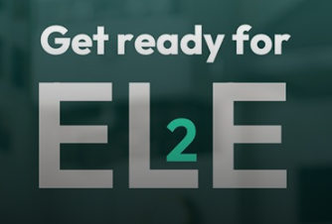

Improving feedback with Turnitin Feedback Studio
Turnitin Feedback Studio is one of the biggest enhancements in ELE 2. It was one of the most popular features among module leads involved in the ELE 2 pilots, as you can see in this three-minute video. It offers a range of options for providing richer feedback to students, while also saving colleagues time and effort.
The key features include QuickMarks, which allow you to quickly create, share and re-use banks of comments that you use regularly in marking. You can then drag and drop these over an assignment. Rubrics allow you to make the marking criteria clear to students up front, and then provide clear feedback to students against each of those criteria. Voice feedback allows you to record audio comments of up to three minutes long.
Of course, you can mix and match any or all of these feedback methods. You can find more about these tools on the Turnitin Feedback Studio Guidance page on Assessment Reimagined. You’ll also find recordings of the recent Feedback Studio online training sessions. Further sessions are being planned.
Departmental training sessions are now taking place on the ELE 2 Coursework Activity tool, which enables assessments to be completely integrated into ELE 2. You can find a comprehensive guide to the tool on the Hubs Academic Staff Guidance page.
The Assessment and Marking Tools table shows the capabilities of Coursework Activity marking tools alongside the additional tools of Feedback Studio, and which is best suited to different tasks.



Signpost your students
Study Zone Digital have some excellent resources for students on Using assessment feedback, including pages on:
- Formative vs. summative assessment
- Understanding your feedback
- Making a feedback log
- Feeding forward: acting on your feedback



Black History Month Feature - the ethnicity awarding gap
For Black History Month we wanted to include a special feature on the ethnicity awarding gap, and what colleagues can do to help close the gap. The TASO report Approaches to Addressing the Ethnicity Degree Awarding Gap suggests the following:
1. Adapting Assessment Practice: Reforming the format or processes of assessments to address the EDAG.
2. Raising Awareness: Workshops and sessions aimed at developing staff understanding of the EDAG and other forms of inequality faced by students.
3. Developing Curricula: Reforming the curriculum to be more inclusive, such as through the inclusion of diverse perspectives or decolonizing reading lists.
4. Running Events: Providing extra-curricular events for students to address the EDAG.
5. Modifying Leadership Practice: Senior leadership teams adapting leadership structures or culture to tackle the EDAG.
6. Using and Developing Learning Analytics: Collecting and analysing quantitative data on the EDAG, including student grades, submissions, attendance, and demographic information.
7. Providing Peer Learning and Mentoring: Students supporting each other as mentors or learning from one another.
8. Incorporating Personalized Support: Providing one-to-one support activities like coaching, mentoring, or tutoring to address the EDAG.
9. Recruiting Staff: Conducting staff recruitment drives to increase diversity, particularly recruiting staff from more ethnically diverse backgrounds.
10. Building Knowledge: Undertaking research, evaluation, or other activities to enhance understanding of the EDAG.
11. Producing Resources: Developing guides for staff and students, such as guidance on reducing the EDAG or creating an inclusive curriculum.
12. Developing Staff Skills: Events and activities aimed at supporting staff's knowledge and understanding of the EDAG through continuing professional development workshops.
Our full degree awarding gap resources are available on SharePoint



Introducing the Educator Development team
The Academic Development team have been undergoing a bit of a 'rebrand'. In recognition of our work supporting all educators - not just academics - we are changing our team name to Educator Development! You can find about more about the team on the About Us page our website.
We feel this is more inclusive and recognises the full range of colleagues we support. We will be phasing out our academicdevelopment@exeter.ac.uk email address to reflect this, so please contact us on eduexe@exeter.ac.uk from now on!



New resource - reimagining assessment reflective tool
The emergence of generative AI – a type of AI that can produce or generate content in a variety of media - is going to be a catalyst for re-imagining assessment. This tool will support you to do just that – taking you through a series of tasks and reflective questions to get you to consider:
- What are you assessing, and why?
- What assessment methods are you using?
- How will you design your assessment tasks?
In doing so, this tool will prepare you to make any module amendments needed for 2024/2025 (the deadline for which is usually in April). Different educators will play different roles in this process, depending on your role (e.g., module tutor, module lead or programme lead). Make sure when looking at this document, and before you make any changes, you discuss your ideas with your programme lead and/or Director of Education and Student Experience.
We have developed a full version of the tool, which we advise you use as part of an away day (which the Educator Development team could deliver!), and a short version.
We regularly deliver bespoke, in-department workshops. If you are interested in us delivering this tool as an interactive workshop, CPD event or away day, please get in touch. Similarly, if you have any questions or feedback on this tool, please contact the Educator Development team on eduexe@exeter.ac.uk.



New resource - Freedom of Speech
Freedom of speech is at the heart of all democratic societies and a foundation stone of higher education. However, there is a need, on occasion, to balance the right to freedom of speech against the need reasonably to protect the rights of others. The Higher Education (Freedom of Speech) Act became law in May 2023.
Promoting a culture of fearless and vigorous debate needs a holistic approach. Compassionate environments, where everyone is enabled to be confident in putting forward their points of view, are part of the dialogic classroom. This new page on the Education Toolkit page brings together resources and guidance on.
- Freedom of speech
- Content (‘trigger’) warnings
- Student co-creation
- Compassionate communication
Freedom of speech and holisitic considerations resources



New EduExe Teams site
To create a space for a community of practice for educators at Exeter, we have set up a new EduExe Teams site. In this site we will share updates, education funding calls, resources, CPD opportunities and calls for contributions as well as providing a space for colleagues to discuss and share education practice.
We have invited all our ASPIRE fellows to join the site, and you can also add yourself!
Join the EduExe teams site



Global Exeter Innovation Fund now open!
Global Classrooms is a new initiative bringing academics and professional services staff together to develop exchanges with global partners including joint learning programmes, business exchanges and research opportunities as well as supporting engagement for students, academics and other educator colleagues internationally.
To develop this initiative Global Classrooms and Global Partnerships are delighted to launch the “Global Exeter Innovation Fund”, which will provide small grants of up to £3500 to enable colleagues to develop Global Classrooms projects with another global institution. Any academic and professional services member of staff from the University of Exeter is eligible to apply for an award.
This call is open from 2nd October - 30th October 2023
Please read the funding Guidance notes
To apply please complete this Application form
Email Peter Michalcik p.michalcik@exeter.ac.uk (External engagement and Global) and Re Oakley r.oakley@exeter.ac.uk (Manager of Global Classrooms) for further information.
Apply for the Global Exeter Innovation Fund



Latest THE Campus - Call for contributions to follow
Teaching international students practical advice from and for HE professionals on:
- What are the key components of effective lifelong learning
- How can an institution support lifelong learning among its students
- How to ensure international students feel welcomed and included in the classroom
- Managing class debates and discussion so all students can contribute regardless of English proficiency
- Designing assignments so that a lack of fluency in English is not a barrier
- Pedagogies that work well for international classrooms
- Leveraging the benefits of international cohorts to boost cross cultural understanding
- Adapting essay feedback for international students who speak English as a second language
- Setting up buddy or peer mentoring schemes for international students
- How to help international students prepare for university life ahead of their arrival
- Supporting a smooth transition into life in a new country and institution
- Helping international students get to grips with the “hidden curriculum”
- Actively nurturing social ties between international and domestic students
- Language training and other focused support that can help international students excel in their studies
- Leading respectful disagreement between students from different parts of the world
- How to guard against unconscious bias/discrimination in the classroom?
Deadline for content: Monday, 16 October

Skills every research manager needs practical advice from and for HE professionals on:
- Become a pro at finding and securing funding
- How to motivate a diverse team
- What it takes to navigate the politics of an institution
- The key to cross-team collaboration
- Working successfully with HR
- Managing staff at different levels
- Project management skills to develop fast
- How to lead with honesty and empathy while driving quality
- Mentoring skills to guide ECRs
- Spotting and nurturing research talent
- Demonstrating the value of your research
- Promoting / communicating research impact
- Become adept at working with policymakers
- Understanding the changing publishing landscape
- The ins and outs of intellectual property
- How to successfully manage international collaborations
Deadline for content: Monday, 30 October
How to turn off and not feel guilty practical advice from and for HE professionals on:
- How set professional boundaries – and stick to them
- Balancing student care against self-care
- Tips for improving productivity
- Enough is enough: how to know when a piece of work is complete
- Advice on preparing for an extended break
- Early warning signs of burn-out
- Ways of working smarter, not harder
- The art of prioritisation
- How time off can enhance the quality of your work
- Strategies for using your holiday wisely
- How to consciously fight a culture of overwork
- Why hobbies and time out make better scholars
- Understanding the art and science of rest
- Advice for casual, contracted and adjunct staff on factoring in down time
- When to take a sabbatical
- How to build breaks into your working day
- Turn your tech into an aid to down time
Deadline for content: Monday 20th November

If you are interested in contributing, you can find the content guides on our website, and can contact eduexe@exeter.ac.uk for further information and to submit your piece!



QAA Collaborative Enhancement Project Call 2023-24
Collaborative Enhancement projects offer a fantastic opportunity for QAA Members to work together to explore areas of shared interest and engage students. Each project will not only benefit the partners directly involved but should develop outputs to support the wider higher education sector – better still, QAA offer funding of up to £10,000 to each project team.
QAA are particularly interested in projects that address:
- Meeting the challenges and opportunities of engaging with generative artificial intelligence (AI)
- Imaginative approaches for assessing knowledge and skills
- Effective approaches to using qualitative and quantitative data to inform decision making about the quality of the student learning experience
- Flexible pathways and modular study
- Delivering awards in partnership with other providers and organisations including perspectives from providers with and without degree awarding powers – we are particularly interested in UK-based partnerships
- Effective models of student engagement
Full details of the areas QAA are interested in within these topics are available on the Collaborative Enhancement Projects 2023-24 web page.



Events happening this month
Supporting Students Mental Health in Higher Education - 2/11
The University of Exeter welcomes you to the seventh seminar in the Transformative Education Seminar Series (TESS) on 'Supporting Students Mental Health in Higher Education'. The seminar will take place on November 2nd from 13:30-16:00 via Teams. Please sign up to attend the seminar here - attendees will be emailed a joining link ahead of the seminar. Please contact s.porter3@exeter.ac.uk with any queries.



EduExe socials this month
EduExe continues to grow our social media presence, sharing updates, best practice and discussing current issues in Higher Education. This month we shared blog posts on:
- Employability 3.0.....2.....1.....Job! - Dr. Constantine Manolchev
- Tips for teaching a large cohort - Professor Beverley Hawkins
- Using unique data sets for online assessments - Dr. Alison Hill and Dr. Nic Harmer
- Embedding wellbeing from the get-go: exploring best practices in teaching that promote student wellbeing - Dr. Julie Pepper and Dr. Katherine Ashbulby
You can also read about Alison and Nic's work on gamification in their recent journal article - and coming to the EduExe blog soon!
We also released the second episode of the EduExe podcast, discussing Content Warnings with Students as Change Agents interns Andrea Namirembe and Ella Taviner.
Don't forget you can follow us on LinkedIn for updates!
Read the EduExe blog
Listen to the EduExe podcast



The EduExe Crossword - the answers




The EduExe wordsearch
The month's challenge is a wordsearch! Once again, if you send us a copy of your completed wordsearch will we reward you with an EduExe reusable coffee mug!
You can also download a word version of the wordsearch.
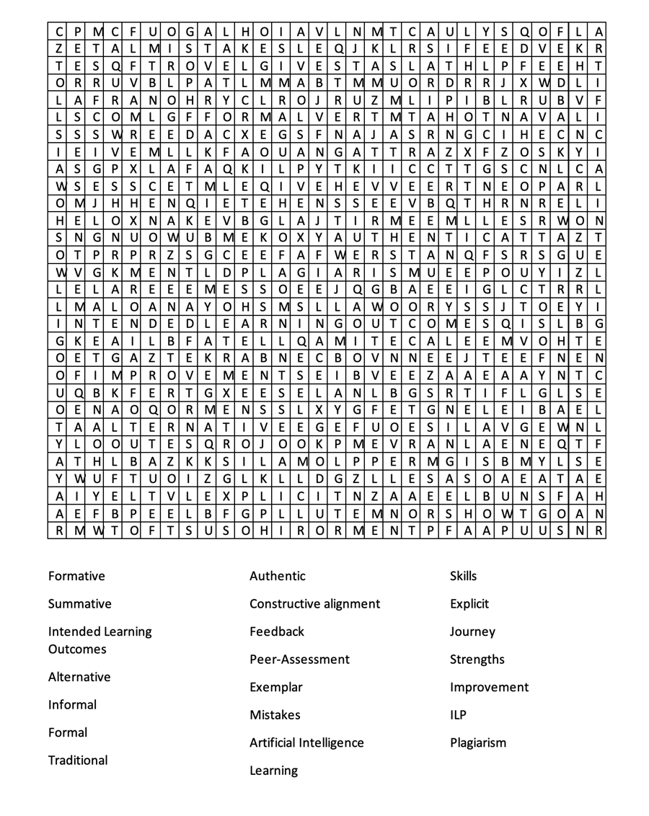

Interested in contributing to the newsletter?
We will have rolling deadlines for submissions each month, so please get in touch with eduexe@exeter.ac.uk if you would like to contribute!
We want your feedback!
The EduExe newsletter is a new initiative, and we would love to hear from you if you have any feedback! You can share it with us anonymously on our feedback form or by email to eduexe@exeter.ac.uk.

Follow us on social media or visit our website to find out more about educator development and enhancement at Exeter!


