Welcome to the September EduExe newsletter!

The EduExe newsletter is an initiative for all colleagues involved in education, focusing on news, updates and all things education development and enhancement. This monthly newsletter includes relevant articles and resources according to the time of the academic year, updates on strategic projects, reminders of key deadlines (i.e. for module amendments) and much more!
If you experience any accessibility issues with this email, you can download a word version on the Educator Development website
This issue we have updates, articles and resources on:
- ELE2 Important Updates and Reminders
- New training and guidance available
- Key information and deadlines for 24/25
- New look and new home for the Teaching Quality Assurance Manual
- Update on GenAI in assessments
- ASPIRE Framework relaunching as EduExe Framework
- Updates to the EduExe Toolkit
- Peer Support 24/25
- Updates from Experimentation and Innovation
- Update on Curriculum for Change
- Update on Student Academic Support project
- THE Campus call for contributions
- Represent your academic community by becoming a Subject Benchmark Statement Advisory Group Chair or Deputy Chair
- On EduExe Socials this month
- Interesting article


ELE2 Important Updates and Reminders
Key information:
- With the annual student progression completed, students have begun enrolling on their 2024/25 modules.
- All 24/25 course pages on ELE2 are made available 1 week prior to the start of scheduled teaching. This will differ depending on the course/programme and when it is scheduled to start. For most term 1 modules (those starting on the 23rd September) this will mean that ELE2 courses were made available to students on Monday 16th September.
NB. You will likely see some fluctuation in enrolled students in ELE2 through the registration period and the start of term.
ELE2 Content Rollover
- Important reminder to prepare your new 2024/25 module pages.
- You can now quickly and easily transfer content from past academic year module pages using the ELE2 Rollover Wizard. Details of this process and full guidance can be found on the Staff ELE Training course.
- In preparation for student access, we advise as a minimum that you ensure any content you don’t want students to see is hidden. It's easy to hide all sections (or specific content) on your course. Instructions for this can be found on ELE.
- Over 600 modules have already been successfully rolled-over using the new wizard since the tool was launched in June this year. Feedback has been largely positive, and we welcome staff to complete our short survey to help to further improve the process and guidance available. If you have used the module page template and would like to provide feedback, please do so via this form.
If you have any questions or concerns about this process, please contact digital-learning-support@exeter.ac.uk
Known issue: Please be advised that some internal links (e.g. a hyperlink from one page/activity to another within the same course) are not updating correctly, so please check these after you import.
Recent updates to ELE2:
- Feedback release notification: Students will now receive an email notification each time feedback is released for the coursework assignments.
- Candidate numbers as unique identifier: The addition of candidate numbers enables module convenors to allocate moderators and markers anonymously. It is now visible for student submissions, allowing more efficient team marking.
- Self-certification counter: students can now navigate to their My Assessment Dashboard and view the number of self-certifications that have been used along with what assessments they have been used for.
- Video-based assessments: A new Panopto plugin has been enabled to support the management of video-based assignments through the coursework tool. More information for staff can be found in our coursework tool guide. Information for students can be found in the Assessment in ELE2 guide.
Further support and guidance available
Please direct all ELE2 enquiries to the following channels
- Queries about setting up your module pages should be directed to digital-learning-support@exeter.ac.uk.
- Queries about accessing your module pages, or about assessments or rubrics, should be directed to your Admin Hub/Info Point.
- You can find more detail here on the full list of where to go for your assessment support needs.
As always, more information about the Digital Learning team, the tools we support, and our current projects can be found on our SharePoint site. You can find details of our upcoming training sessions on our bookings page, or book a 1:1 session with a member of the team here.


New training and guidance available
We’re excited to introduce a range of new guidance and training opportunities for you to explore throughout the upcoming academic year.
- Introduction to Universal Design for Learning (UDL): Discover the principles of UDL and how to create more inclusive learning experiences.
- Applying UDL to the ELE Template: Learn how to incorporate inclusive learning seamlessly in ELE.
- Assessment Design & Redesign: Re-imagine your assessment strategies with a focus on authentic and inclusive design.
We can also offer 1:1 support on how to design your module content around the optional ELE template.
Reach out to the Learning Design Team at learningdesign@exeter.ac.uk for more information or to book a session.
You can also book time with the learning design team to discuss any learning design topic using Book Time with Digital Learning.


Key information and deadlines for 24/25
The Programme Design and Quality Enhancement (PDQE) team offer expert guidance on the entire lifecycle of programme and module development, amendment, and withdrawal activities. PDQE work in partnership with Faculties to create high-quality, market-aligned and efficient portfolios.
Although we have just begun the 24/25 academic year, this document provides a quick reminder of the key information and deadlines for making changes to modules and programmes for forthcoming years, including:
- New modules, module amendments and module withdrawals for 2025/26
- Minor and moderate amendments to programmes for 2025/26
- Programme withdrawals/interruptions for 2025/26
- New programmes and significant amendments for 2026/27
Further information and reminders will be shared over the coming months.
Contacts:
- Environment, Science and Economy: ESE-quality@exeter.ac.uk
- Health and Life Sciences: HLS-quality@exeter.ac.uk
- Humanities, Arts and Social Sciences: HASS-quality@exeter.ac.uk
- New Programmes: Programmedesign@exeter.ac.uk

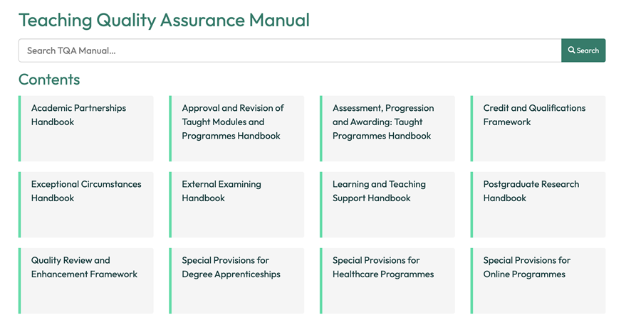
New look and new home for the Teaching Quality Assurance Manual
Colleagues involved in delivering or supporting teaching, learning and assessment are advised that the reformatting and migration of the Teaching Quality Assurance (TQA) Manual has been completed and the 2024/25 version is now live.
As the TQA Manual will now look different and be navigated differently, colleagues are encouraged to visit the web pages and familiarise themselves with them, especially Handbook, Chapters or sections that they refer to frequently. They will also need to update any links to the TQA Manual from other web pages or documents, although a redirection has been put in place to the new Home Page.
It should be noted that the no changes have been made to the content of the TQA Manual unless recommended for approval by the Education Board or the Postgraduate Research Board in June 2024, or via subsequent Board Chairs’ Actions. Any Chapters of Handbooks or Frameworks that have been amended will be marked as ‘Reviewed June 2024’.
Unless there are exceptional circumstances, or a well justified rationale is put forward, no further changes will be made to the TQA Manual, and this will remain the definitive version throughout the 2024/25 academic year. This is an important step being taken to maintain version control and adhere to external regulatory requirements and sector best practice.
Should anyone have any difficulties accessing or navigating the TQA Manual in its new home, or identify any errors or omissions as a result of the reformatting and migration, please email Education Policy, Quality and Standards at educationpolicy@exeter.ac.uk.
The new home page for the TQA Manual

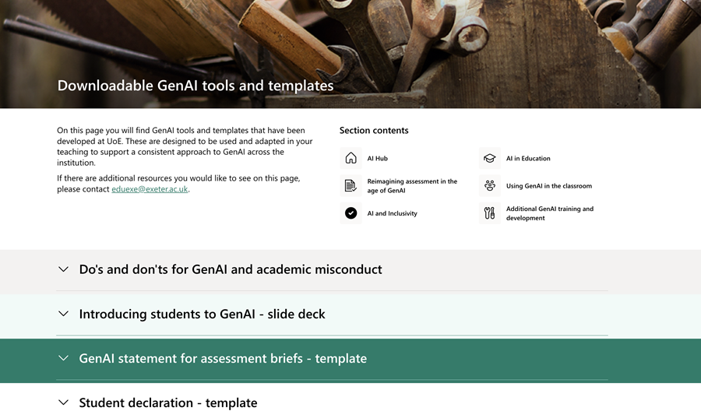
Update on GenAI in assessments
In response to requests from DESE Engage and the SACO forum, we are introducing two new requirements from September 2024 to provide clarity around the use of GenAI in assessments for both staff and students, and to help prevent academic misconduct. This comes in the form of a categorisation framework on use of GenAI to be included in assessment briefs, and a student declaration.
Separate communications will be going out to students in the w/c 16th September.
You can find out more about tis update on the EduExe blog
To support this, the Educator Development, Learning Design and Academic Skills teams have developed a suite of new resources on GenAI and assessment.


ASPIRE Framework relaunching as EduExe Framework
The Educator Development team and School of Education have recently reaccredited our AdvanceHE fellowship framework. As part of the reaccreditation process, we will be relaunching the ASPIRE Framework from September 2024 as the EduExe Framework.

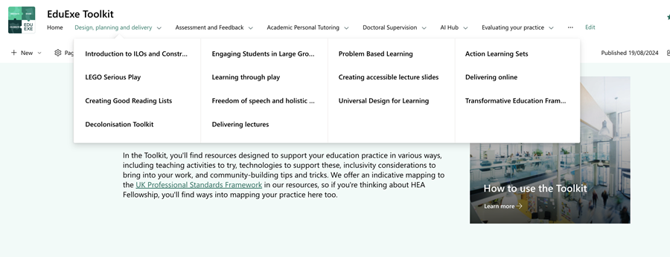
Updates to the EduExe Toolkit
The Educator Development team have been busy over the summer giving the EduExe Toolkit a makeover, improving the navigation and digestibility of resources in response to your feedback. We also have new pages on:
- Designing MCQs
- Creating accessible lecture slides
- An introduction to decolonisation in doctoral supervision
- Supporting the PGR upgrade
- Effective support for PGRs with ILPs
- Supporting part-time PGRs
We have also reviewed and updated the AI hub, to include a new page on downloadable GenAI tools and templates.
We have also launched a brand new toolkit on inclusive education, disability and reasonable adjustments - developed collaboratively by he Educator Development team, Wellbeing & AccessAbility Services, Disability Network, Neurodivergent and Disabled Students' Society, members of staff from around the University and Education Incubator fellows

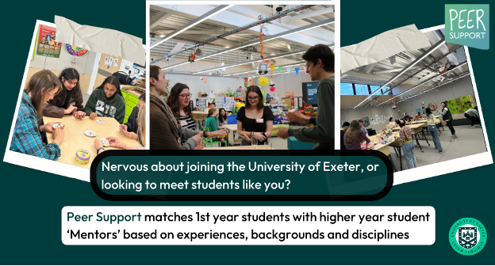
Peer Support 24/25
Peer Support coordinate different peer learning schemes across the University. Schemes are either led by Faculty staff (e.g. Medical Sciences Peer Mentoring, MFL PAL) or by the Peer Support team, and support students academically or pastorally.
New schemes for 2024/25 include:
- Engineering PALs (Peer-Assisted Learning sessions)
- Physics PALs
- PGR-PGR Peer Mentoring
Students who are carers can also now join the Care Leaver and Estranged Student Peer Mentoring scheme. Students can join most schemes throughout the year, but details about all schemes (including campus and eligibility) are on our website.
Find out more on the Peer Support website


Updates from Experimentation and Innovation
Welcoming Grand Challenges to the Team
We are excited to announce that Grand Challenges is now part of our team! This annual project week takes place in the first week of June and allows students to collaborate in interdisciplinary groups. Together, they tackle real-world issues like climate change, mental health, social inequality, global security, and the future of food.
Learn more about the impact of Grand Challenges here.
Experimentation Microgrants on the Horizon
Applications for the Experimentation Grants, offering up to £500, will soon be open to the University of Exeter community. These small-scale grants support experimentation with learning and teaching challenges, helping you to ideate, test, and develop solutions.
Twelve grants will be awarded on a rolling basis over the 2024-2025 academic year. Applications go live later this month!
Learn more about Global classrooms experimentation grants
Learn more about Exeter Education Incubator experimentation grants.
Join the Future17 Cohort as a Mentor or Student
We are seeking academic mentors and student participants for this year’s Future17 module, which focuses on tackling challenges related to the UN Sustainable Development Goals. Open to most undergraduate and postgraduate students across disciplines, the programme is supported by a global network of universities and industry partners. Academic mentors play a key role in guiding student groups, providing research support, and helping meet project deadlines.
The mentor role is a valuable opportunity for those pursuing fellowship through the EduExe Framework, where it can be used as a case study as part of your application. In addition, we are offering 45 SWARM hours per academic year for academic mentors. If you're interested, please contact University of Exeter Academic Lead, Hollie Kirk at h.kirk@exeter.ac.uk, or Future17 Manager Re Oakley at r.oakley@exeter.ac.uk.
​​​​​​​Don’t forget to also share this amazing programme with your student cohorts, find out more here!

Update on Curriculum for Change
The Curriculum for Change (C4C) programme is working to realise our strategic commitment to develop a distinctive and sustainable model for education by 2030. In the initial discovery phase (Feb-Sept 2024), the programme established representative Task and Finish / Working Groups to consider how we can challenge and inspire our community of learners from every background to thrive, develop the skills they will need for the future and lead the change the world needs. The recommendations from these groups were approved to progress to implementation and/or more detailed strategic cases by UEB in July 2024:
- Review all UG programmes and modules using co-created course and assessment design principles.
- Establish, pilot and maintain a curated list of minor programmes (building on current WPi programmes) deliverable at scale.
- Prepare a business case for moving to a three-teaching term model for the academic year.
- Embed an Exeter-wide skills taxonomy and portfolio into all UG programmes for credit.
- Prepare a business case for and pilot a core mixed-model interdisciplinary immersive module for all programmes.
Work is underway to establish cross-institutional development and delivery groups to progress thinking and deliver plans in each area across 2024/25. The C4C Programme Board relaunch the C4C staff SharePoint site with information for staff about the proposed changes and timeline for change later this month. In the meantime, please direct any questions to curriculumforchange@exeter.ac.uk.

Update on Student Academic Support project
The Student Academic Support (SAS) project was Highly Commended by judges in the Best New Access, Participation or Progression Project at the recent Success for All Awards Conference. The SAS project, led by Professor Nicky King (Associate Pro Vice-Chancellor (APVCE) Education - Faculty of (ESE)) and Professor Adam Watt (Deputy Pro Vice-Chancellor, Faculty of (HASS)) is implementing a new model for proactive, data-informed and digitally enabled student academic and pastoral support. At the heart of the model are the Pastoral Mentors- new academic staff embedded within departments who are fully allocated to providing student support and signposting to services across the institution. An initial pilot in HASS Penryn and Physics at Streatham was run in the 23/24 academic year and received positively by academic staff and students with numerous benefit and success measures identified including:
- Pastoral Mentors proactively and consistently reach out to students to offer academic and pastoral support.
- Academic and professional services staff work collaboratively with Pastoral Mentors to support students.
- Students receive and/or are signposted to academic and pastoral support that allows them to progress in their studies.
- Students report increased satisfaction and reduced variability with their experience of academic support.
- Departments report increased student engagement, a reduction in non-continuation / withdrawal rates and improvement in student outcomes (with a focus on under-represented, disadvantaged, and international students).
Since the pilot in HASS Penryn in October 2023, the Pastoral Mentor community has grown to half of all departments across our Streatham, Penryn, and St Lukes Campuses. By September 2025, students from all departments will have access to Pastoral Mentor support. Students and staff can learn more about the role of Pastoral Mentors and how to contact them via our new webpage and video here: https://www.exeter.ac.uk/students/pastoral-mentors/.


THE Campus call for contributions
Through our partnership with THE Campus, we receive regular calls for content, as well as a rolling call for contributions on THE Campus key topics. The current calls for content are on:
- The business of online education - deadline for content: Monday, 23 September
- COP 29: the green campus - deadline for content: Monday, 7 October
- Indigenous voices in higher education deadline for content: Monday, 4 November
If you are interested in contributing to THE Campus, please contact eduexe@exeter.ac.uk with your pitch and download the Campus editorial guidelines.
Find out more about the calls on LinkedIn


Represent your academic community by becoming a Subject Benchmark Statement Advisory Group Chair or Deputy Chair
You’re invited to express your interest in becoming an Advisory Group Chair or Deputy Chair for one of the six Subject Benchmark Statement reviews which will take place during 2025-26:
- Architecture
- Art and Design
- History of Art, Architecture and Design
- Social Work
- Sociology
- Social Policy
More information on how to submit an expression of interest, along with details of what the roles involve, is available on the call for expressions of interest webpage. The deadline to submit an expression of interest is Friday 18 October 2024 at midday.
Find out more on LinkedIn


On EduExe socials this month
EduExe continues to grow our social media presence, sharing updates, best practice and discussing current issues in Higher Education. Over the summer we have been busy uploading some of our EduExe Festibal sessions to our YouTube channel, including:
- Alternative assessments for developing personal leadership skills – Dr Michelle Trottier, Dr Julie Pepper, and Dr Alison Sydenham
- Game-based learning and inclusivity – Dr David Yuratich
- Decolonising approach to curriculum transformation in diagnostic radiography – Dr Katie Fordyce (LSBU)
- Bridging the Gap – Naabil Khan
- Putting rigour into reflection, why TEXL is an essential platform for educators – Dr Michelle Mahdon, Jackie Bagnall and Prof Beverley Hawkins
- Facilitating Inclusive Learning Communities – Sian Robinson
- Transformative Education Framework at the University of Exeter – Prof Vrinda Nayak and Sean Porter
...with more recordings to follow soon!
Watch talks from the EduExe Festival 2024 on YouTube!
If you are interested in contributing to the EduExe blog this academic year, please contact us on eduexe@exeter.ac.uk!
Read the EduExe blog
Don't forget you can follow us on LinkedIn for updates!


Interesting article
Colleagues may be interested in the article 'Generative artificial intelligence (AI) in higher education: a comprehensive review of challenges, opportunities, and implications' by Michal Bobula, UWE in the Journal of Learning Development in Higher Education!
Read Generative artificial intelligence (AI) in higher education: a comprehensive review of challenges, opportunities, and implications

Interested in contributing to the newsletter?
We will have rolling deadlines for submissions each month, so please get in touch with eduexe@exeter.ac.uk if you would like to contribute!
We want your feedback!
The EduExe newsletter is a new initiative, and we would love to hear from you if you have any feedback! You can share it with us anonymously on our feedback form or by email to eduexe@exeter.ac.uk.

Follow us on social media or visit our website to find out more about educator development and enhancement at Exeter!


Join the EduExe teams site to connect with educators across the University

