Emergency Response to a Major
Incident Plan

Version 14.0x (October 2025)

Confidential

Response Level: Silver

Plan Objective: To provide a framework for the University’s emergency response to a major incident, where the resources needed to deal with the emergency exceed routine Estate Patrol deployments.
Plan Scope: Streatham and St Luke’s campuses
Purpose: Identifies key personnel, tasks and strategies for responding to the emergency phase of a major incident.
To be used by: University emergency response personnel

IN THE EVENT YOU ARE ABLE TO SAFELY REACH YOUR DESK

DO NOT FORGET

- Your copy of this plan
- Your mobile phone and personal items (e.g. car keys, wallet/handbag, jacket, UniCard)
- Your laptop, mains lead, the business continuity plans for your area, mobile phone charger, power bank, etc.
- To delegate your current position and duties, if and where appropriate

Contents are listed at the rear

SECTION A
UNIVERSITY INCIDENT MANAGER

EMERGENCY PROCEDURES AND TASKS
The steps outlined below are an aide-memoire for the University Incident Manager. More detailed information is included in Section C - Guidance.
Task  ID | Task | Guidance  (see Section C)
 | Initial response
1 | Check that Estate Patrol has implemented the alert cascade, including contact with the emergency services and summoning of First Aiders if there are casualties. | 5.1
2 | Appoint admin support and open activity and communication logs. | 6.1  Appendix H (Activity log)
3 | Arrange a rendezvous point for the emergency services. | 6.1
4 | Put on the orange University Incident Manager vest. | 6.1
5 | Assess scale, duration and impact of the incident: use ETHANE mnemonic:  Exact location What is the exact location or geographical area of the incident?  Type of incident What kind of incident is it?  Hazards What hazards or potential hazards can be identified?  Access What are the best routes for access and egress?  Number of casualties How many casualties are there, and what condition are they in?  Emergency Services List those services present and those required. | 6.2  Appendix G1 (ETHANE form)  ETHANE details can also be recorded and shared via the JESIP mobile phone app
6 | Undertake a dynamic hazard assessment, with emergency services if present.
7 | Implement evacuation, dispersal, or shelter-in-place measures if there is obvious danger. Otherwise, await instructions from the emergency services. | 4 (maps and Streatham zones)  5.2 (assembly & shelter points)  6.2 (implementation)  6.6 (groups with specific needs)  Appendix A (bomb threats)  Appendix B (CBR incidents)  Appendix C (firearm and weapon attacks)
8 | Meet the emergency services at the scene and establish communications with responders. | 6.2
9 | Command and control the University’s resources at the scene by liaising with others (e.g. Estate Patrol, Evacuation Officer, Safety Team, Estate Services, Facilities Management, Faculty representatives). SBAR mnemonic provides prompts:  Situation What is happening at the scene?  Background Any additional information e.g. action taken?  Assessment Is the situation deteriorating / stable / improving?  Recommendation / Requirement What do you think needs to be done / what do you require? | 6.1  Appendix G2 (SBAR form)
10 | Request assistance from the Communications Team with regard to informing the University community, the public and media. | 6.3
11 | Arrange traffic management and request additional Incident Support from Facilities Assistants if required (at St Luke’s, it may be beneficial to draw support from Streatham). | 6.4
12 | Assess security measures and request additional resources if necessary. | 6.5
13 | Consider establishing a cordon (if emergency services are not present), according to the type of incident. | 6.7
14 | Consider evidence collection and recording witnesses’ contact details. | 6.8
15 | Provide updates by mobile phone or radio to the Director of Commercial, Residential and Campus Services / delegated University Incident Response (Gold) team member as the situation progresses. Consider nominating a runner. | 6.1
 | Stand down
16 | When it is safe to do so, announce ‘all clear’ and arrange for an orderly return of people. | 6.9
17 | Request that the Director of Commercial, Residential and Campus Services / delegated University Incident Response (Gold) team member holds a ‘hot’ debrief and schedules a ‘cold’ debrief for a later date. | 6.10 and 7

SECTION B
SCHEMATIC SHOWING RESPONDERS’ ROLES AND RESPONSIBILITIES
Incident happens
Witness raises alarm
Call 999
Alert Estate Patrol
Alert key University staff
including First Aiders
UNIVERSITY INCIDENT MANAGER
(ORANGE VEST)
UoE GOLD INCIDENT RESPONSE TEAM
Support University Incident Manager, strategic decisions, media and communications
ALERT
C O O R D I N A T I ON
A C T I O N
EMERGENCY SERVICES INCIDENT COMMANDERS Jointly assessed response: PRIMACY
Bomb squad, hazardous area response, temporary morgue, etc
RVP
Evacuate, shelter, disperse instruct-tions.
Cordon formation & control
Fire – contain incident, rescue people
Police – collect evidence, seek suspects, control traffic & people
Ambulance – triage and casualty clearing
University Incident Support (UIS) – front line action
Effect evacuation / shelter / dispersal / traffic control / gather witness details and evidence
Utility providers isolate / make safe gas, water & electricity
University specialist services
Grounds & Facilities Mgt: contribution to UIS.
Insurance, Audit & Risk Team liaison with Loss Adjuster & BC Plans
Persons in Charge & Evacuation Officers: building layout, activities, hazards
Safety Team: hazards, safety, evidence, liaison with enforcement agencies, Local Authority, etc
Estate Services: utilities, engineers, surveyors
Staff with specialist knowledge e.g. chemical hazards, vulnerable areas

Key:
Emergency services. The Police will have primacy of the incident, will establish command & control, and will be the lead agency.
University of Exeter
University of Exeter assisting emergency services or under the direction of the emergency services
Utility provider
Lines of communication between commanders
Other communication lines

SECTION C
GUIDANCE

Aim
The aim of this plan is to provide a framework for:
- the University’s emergency response to a major incident, where the resources needed to deal with the emergency exceed day to day Estate Patrol deployments
- the safe and orderly large scale evacuation of all, or part of, the University’s Streatham and St Luke’s campuses
- minimising any adverse effects of a major incident on the campuses and campus users

Objectives
- To outline the roles of key staff during a major incident
- To outline the University’s procedures for effecting a partial or complete large scale evacuation
- To acknowledge circumstances where a ‘shelter-in-place’ response is appropriate (i.e. keep people within a building where this is considered the safer option)
- To outline the communication plan for providing information to students, staff, visitors, contractors, the media and other third parties during and after a large scale evacuation / shelter-in-place

Scope
This plan covers the Exeter campuses. It provides a framework for a large scale evacuation (e.g. more than one building), or shelter-in-place response to an incident. It works alongside other response arrangements such as building evacuation procedures, the Welfare Incident Plan, and Communication Major Incident action cards.
This plan does not cover University buildings outside the two Exeter campuses, for example, James Owen Court and Rowancroft.
Where third parties occupy buildings on the Streatham or St Luke’s campuses, it is the responsibility of the third parties to effect an evacuation of their buildings. They should be made aware of this guidance and invited to participate in the large scale evacuation.

Campus profile

Map of Streatham Campus
Streatham is the largest of the University’s campuses. It has academic buildings, libraries, a sports park, conference facilities, a nursery, catering and shopping outlets, student residences, a chapel, a theatre and extensive grounds. Some of the University’s key partners operate from the campus; for example, the Northcott Theatre, Tops Exeter Nursery, INTO and UPP occupy whole buildings. In some cases, business tenants occupy parts of buildings, for example, the Forum, Innovation Centre and Amory. During construction periods, construction sites are usually under the control of the contractor. There is open access to the rest of the campus for both pedestrians and vehicles.

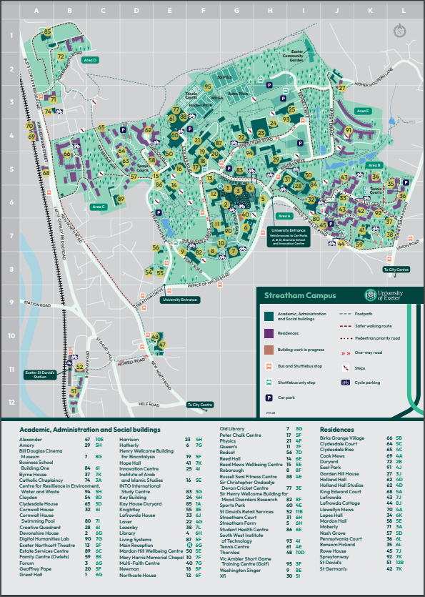

Zone Map of Streatham Campus
This map of the Streatham campus shows zones based on geographical layout, to assist with a large scale evacuation, and the identification of assembly and shelter points.

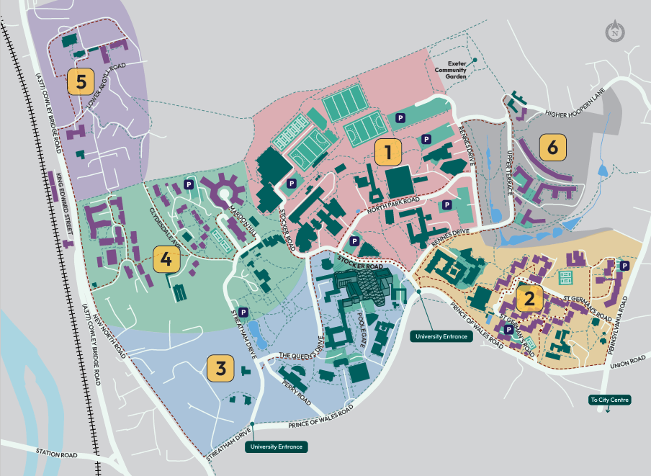

Zone 1, Pink
Area mainly north of Rennes Drive, including Amory, Physics, Peter Chalk Centre, Geoffrey Pope Building, Biocatalysis Centre, INTO, Living Systems, Laver, Harrison, Innovation Centre, SWIoT Centre, CREWW building, Sports Centres (including Tennis and Cricket Centres and sports pitches), and Car Parks A and B.

Zone 2, Yellow
Eastern side of the campus including Xfi, Streatham Court, Building:One, Lafrowda buildings, Exeter Halls, Cornwall House and Tops Exeter Nursery.

Zone 3, Blue
Area between Prince of Wales Road and Stocker Road, excluding Lafrowda and student residential areas (see Zone 2). This area includes Knightley, Redcot, Washington Singer, Chapel, Roborough, Old Library, Hatherly, Devonshire House, Queens, Northcote House, Northcott Theatre, Great Hall, Forum, and Streatham Farm.

Zone 4, Green
Western side of campus including the Institute of Arab and Islamic Studies, Reed Hall and Annexes, and student residences east of King Edward Street including Holland Hall, Birks and Clydesdale.

Zone 5, Purple
Duryard, including Moberly.

Zone 6, Grey
East Park and Garden Hill House.

Map of St Luke’s Campus
St Luke’s campus is located near the city centre, off the Heavitree Road. It includes academic buildings, a library, café, sports centre and chapel. There is a car park on the perimeter of the campus (accessed via Magdalen Road). Although there is no vehicular access for the public, all parts of the St Luke’s campus are accessible by foot and by cycle.

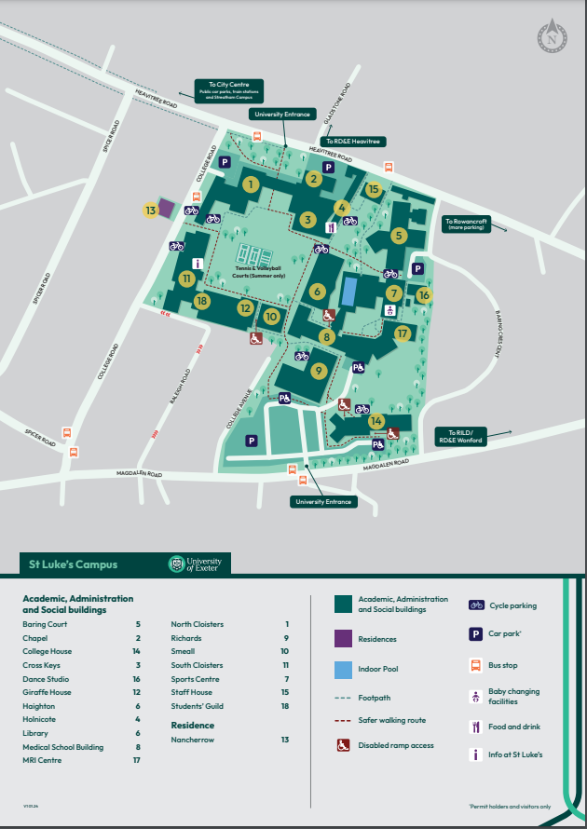

Invoking the Plan
This plan should be used when the University’s usual coping mechanisms are inadequate to bring the incident under control and manage the response. It can be invoked by:
- Head of Security, Parking and Transport Operations
- Security Operations Manager
- Designated University Incident Managers at the St Luke’s campus

Alert cascade

The following diagram illustrates how the alert cascade should be implemented:
Person at scene
Emergency Services (999)
Head of Health & Safety

Kate Lindsell
Estate Patrol
(01392 72 2222)
Director of Commercial, Residential and Campus Services
Peter Scargill
Head of Security, Parking and Transport Operations
(<<removed>>)
Dan Nicoll

St Luke’s University Incident Managers (if appropriate)
Facilities Assistants (Incident Support, contact by radio)
Other internal notifications deemed appropriate by Estate Patrol / Director of CRC

Estate Patrol holds mobile phone and out of hours contact numbers for key members of University staff. These will be used if necessary. The University Incident Manager may use their discretion to make direct contact with the Senior Vice President and Registrar & Secretary or other member of the Gold Incident Response Team (IRT) if the Director of Commercial, Residential and Campus Services is not available, or if the gravity of the situation dictates. Alternative Gold IRT contacts include:
- Deputy Registrar and Executive Divisional Director of Education and Academic Services
- Executive Divisional Director of External Engagement and Global
- Chief Financial Officer and Executive Divisional Director of Finance, Infrastructure and Commercial Services
- Executive Divisional Director of Human Resources
- Business Manager to the Registrar & Secretary (Gold team secretary)
The role of the Director of Commercial, Residential and Campus Services during the emergency phase of an incident is to support the University Incident Manager and the response operations, and to act as a conduit for the sharing of information between the University Incident Manager and the Gold IRT. The intention is to protect the University Incident Manager from frequent internal enquiries, and to provide support by making immediate high level decisions. This approach should also free the SVP and Registrar & Secretary to consider strategic matters.

Evacuation, shelter and dispersal
In some emergency situations, an evacuation may be necessary to move people in an organised manner away from a hazardous building or area, to reach a safe place. In other circumstances, for example, release of hazardous materials, or risk of flying debris, greater protection might be afforded by a shelter-in-place strategy within a building. However, people cannot be held against their will. Finally, if the disruption is likely to last a long time, or the danger area is extensive, it could be better for people to disperse from campus altogether.

The emergency services have primacy and the University should follow their instructions. In the absence of instructions from the emergency services, the University Incident Manager (see 6.1 below) should decide which course of action to take and has the authority to act.

Outdoor assembly points and indoor shelter areas have been identified within each of the Streatham zones. If a zone is evacuated, the University Incident Manager should specify which assembly and shelter points should be used in the unaffected zones. The University Incident Manager should notify the Health & Safety Team to arrange for a dynamic risk assessment and ongoing monitoring of the assembly point or shelter area. A registration form for use at indoor shelter areas is shown in Appendix E.

Zone | Outdoor assembly points | Indoor shelter areas
1 | See Appendix D | See Appendix D
2 | See Appendix D | See Appendix D
3 | See Appendix D | See Appendix D
4 | See Appendix D | See Appendix D
5 | See Appendix D | See Appendix D
St Luke’s | See Appendix D | See Appendix D

More detailed information about the indoor shelter areas can be found in Appendix D.

Emergency Response Phase

Command and control structure
The University has a Gold, Silver, Bronze response structure. The University’s Gold Incident Response Team is convened by the SVP and Registrar & Secretary; its role is to provide strategic leadership, if required. The Director of Commercial, Residential and Campus Services should inform the Gold IRT Chair so that consideration can be given to convening the team.

The Silver level response is tactical, i.e. determining how the incident will be managed on the ground. If the emergency services are summoned, each will nominate a Silver Commander, Silver denoting the function rather than the rank of the individual. These personnel wear chequered tabards so that they can be easily identified. The University’s Incident Manager should wear an orange University vest marked ‘University Incident Manager’, (available from the Estate Patrol Office, Estate Patrol vehicle and St Luke’s Porters’ room, South Cloisters G47). Only one person should wear the vest at any time. If the University Incident Manager role is transferred from one person to another, the vest should be handed over to signify the transfer of responsibility. The person transferring responsibility should remain with the new University Incident Manager to share background knowledge of the incident and actions taken.

The order of preference for the person assuming the University Incident Manager role is shown below:

University Incident Manager – order of preference:
- Head of Security, Parking and Transport Operations
- Security Operations Manager
St Luke’s site specific arrangement (during normal working hours)
To help ensure a rapid response is mobilised prior to the arrival of Estate Patrol, the following members of staff are designated University Incident Managers at the St Luke’s campus:
- Head of Security, Parking and Transport Operations
- Julian Vinnels (hybrid working)
- Vicki McKenna (hybrid working)
- Sam Bailey (hybrid working)
- Ross Chalmers (hybrid working)
The role of the University Incident Manager is to:
- make decisions to help protect welfare prior to the arrival of the emergency services
- make decisions to contain the incident
- command and control the University’s resources at the scene
- liaise with Estate Patrol
- liaise with the emergency services
- liaise with the Director of Commercial, Residential and Campus Services (or alternative Gold IRT member)
- maintain a log of events, decisions and communications

Communication methods between the University Incident Manager and the Director of Commercial, Residential and Campus Services include mobile phones and the University’s radio system. A runner may also be nominated by the University Incident Manager or Director of Commercial, Residential and Campus Services. In addition, the Director of Commercial, Residential and Campus Services (or alternative Gold IRT member) may visit the University Incident Manager to witness the scene but should avoid impeding operations by their presence. Experience has shown that it is helpful for the Estate Patrol Control Room to receive information from the University Incident Manager about which senior staff are at the scene.

The Estate Patrol Control Room performs a vital coordination role, in support of the University Incident Manager. In a fast-moving situation, it is recognised that a member of the Communications Team may need to be based in the adjacent office, to facilitate timely, accurate communications with the campus community.

The University Incident Manager may wish to assign admin support from within Estate Patrol to help with maintaining logs. Staff from other departments may also be able to assist; in particular, the following member of staff is familiar with this role and has volunteered to help:
- Laura Capell, Facilities Mailroom Operative

A pro-forma ETHANE report form, Activity Log, Call Log and Casualty List form are included in the Appendices (G1, H, I and J respectively), to assist with record keeping. An SBAR form is included in Appendix G2. This is a structured communication tool that can be used as a prompt when requesting assistance; it can also be used by the member of staff receiving the request. The purpose of SBAR is to help ensure an adequate and concise exchange of information, with a clear understanding of the action that is being requested.

The Bronze response focuses on practical operational matters, e.g. directing traffic, and implementing cordons.

If the emergency services are summoned to the Streatham Campus, car park may be used as a Rendezvous Point (RVP). The RVP at St Luke’s is likely to be. If the nature of the incident makes these locations unsuitable, the emergency services will seek an alternative and may require advice from the University Incident Manager. The RVP provides a place where all resources arriving at the campus / scene can be briefed and directed.

Guidance for Air Ambulance landings can be found in Appendix F.

It is possible that the emergency services will also open a Tactical Coordinating Centre (TCC) at <<removed>> . It is possible for the University’s CCTV to be viewed at the TCC. If the University receives a request for representation at <<removed>>, the Director of Estate Services or other delegated member of the University’s Gold IRT should attend.

<<removed>> has been designated by the University as an Incident Command Centre or Silver meeting room. This room is situated on <<removed>>. It should be opened in accordance with the Silver Meeting Room Invocation Procedure Note.

Implementation
The University Incident Manager will ascertain what has happened and liaise with the University’s Gold IRT via the Director of Commercial, Residential and Campus Services or, if absent, another member of the Gold IRT. In extreme cases, where there is an immediate threat to welfare, the University Incident Manager has authority to issue evacuate / disperse / shelter-in-place instructions before the emergency services arrive. When present, the emergency services will assume primacy and direct the action to be taken.

It is important to ensure public safety with minimum disruption to the University community. The University Incident Manager will work in collaboration with the emergency services to assess whether evacuation / dispersal / shelter-in-place is necessary. Buildings can provide significant protection against some hazards (e.g. a chemical or biological release). If it is decided that a large area needs to be evacuated on the Streatham campus, the Zone Map can be used as guidance (see 4.2 above). If several zones of the Streatham campus are affected, it is likely that a staggered evacuation process will be used. However, in the case of a major incident at St Luke’s, it is likely that the campus will be fully evacuated. The University Incident Manager will assess, in conjunction with the emergency services, which evacuation routes are safe to use.

If the numbers of evacuees are too large to accommodate on the affected campus, evacuees will be asked to return home if possible, or go to shelter points at the other campus. Once the emergency services have taken control of the incident, they may liaise with the local community to find nearby places of shelter (e.g. pubs and local halls).

Devon County Council (DCC) provides Rest Centres if there is a serious incident involving more than 30 people for a prolonged period of up to three days. The emergency services will liaise with DCC if necessary. However, if the emergency services are not present, the University can contact the DCC Duty Officer on <<removed>>.

Communication
Communication with the University community / public will be achieved by one or more of the following methods:

Method | Description | Responsibility
Loud hailer | Public message announcement from outdoor or indoor location | Head of Security, Parking and Transport Operations, or Estate Patrol staff
All-staff and all-student email | Email message sent to all staff and students of the University, and key contacts of third party organisations based on campus. | Executive Divisional Director of External Engagement and Global, or if absent, delegated member of staff
Targeted email | Email message sent to a target audience, e.g. Directors of Faculty Operations / Professional Services Leadership Team | Executive Divisional Director of External Engagement and Global, or if absent, delegated member of staff
SafeZone app notification / text message / email | SafeZone app notification / Text message / email sent to staff, students and third parties based on site | Executive Divisional Director of External Engagement and Global, or if absent, delegated member of staff
Digital Signage | Messages on large screens in public areas of the University | Executive Divisional Director of External Engagement and Global, or if absent, delegated member of staff
Media | Local TV and radio broadcasts | Executive Divisional Director of External Engagement and Global, or if absent, delegated member of staff
Face-to-face | Instructions given in person by staff responding to the incident (e.g. traffic control) | University Incident Manager and University Incident Support
Physical Signage | Strategically placed on entry to affected area, buildings, etc. | Executive Divisional Director of External Engagement and Global, or if absent, delegated member of staff
Social Networking Media | Public message broadcast via the University’s Facebook, X or other social media accounts | Executive Divisional Director of External Engagement and Global, or if absent, delegated member of staff

All communications with the media should be managed by the Communications Team; it is important that other members of staff do not give interviews or make statements to the press without prior approval. It is noted that if the emergency services are present, a Police Media Liaison Officer might be appointed to coordinate communications with the media, in which case the University will defer to this Officer. If representatives from the Press are present on campus, the Executive Divisional Director of External Engagement and Global may designate a Press area. The University should bear in mind the need to communicate with:

- students
- staff
- visitors
- contractors
- tenants
- service providers (including Stagecoach and suppliers delivering to the campus)
- local community
- other University stakeholders

Traffic management
Depending on the circumstances, it may be necessary for the University Incident Manager to assist the police with the control and direction of traffic, to ensure emergency vehicles can access and leave the site, and to prevent vehicles from entering a dangerous area. This might involve, for example, preventing vehicles from leaving the main car parks, or preventing non-emergency vehicles from entering a campus. Estate Patrol would usually carry out this role but might have insufficient personnel during a large-scale emergency. Therefore, Facilities Assistants who have undertaken traffic management training, and who are equipped with yellow high visibility Incident Support vests, may be asked to assist Estate Patrol with traffic management. Consideration should be given to maintaining radio silence on the Facilities Assistants’ radio channel, except by those Facilities Assistants involved in the response. Staff assigned to meet and direct the emergency services should be briefed with essential information using the ETHANE mnemonic (see Appendix G1).

Crime prevention
Each building has designated Fire Marshals who sweep the premises during a fire evacuation to ensure that nobody is left inside, then report to the Evacuation Officer (in accordance with the University’s Management of Emergency Evacuation (Buildings) Protocol). When the emergency services have removed any cordons around the building, the University Incident Manager should consider how security arrangements can be safely implemented, to prevent unauthorised entry to the building. This may include a request to senior management for permission to engage an external firm. CCTV monitoring equipment is also an important resource for crime prevention. Estate Patrol can monitor images in real time and can record them. If Estate Patrol Officers notice suspicious activities, they can investigate or call the police.

Provision for groups with specific needs
Personal Emergency Evacuation Plans (PEEPs) are drawn up for students, staff and conference guests with a disability, who may require assistance. These should be put into effect during a large-scale evacuation. Consideration should be given to the needs of the Tops Exeter Nursery occupants if Zone 2 is to be evacuated. Due to the difficulties of relocating babies and young children, the nursery manager might decide to shelter-in-place rather than evacuate the building.

Cordons
The University Incident Manager may deem it necessary to impose a cordon before the emergency services arrive. Cordon tape is available from the Estate Patrol van and from the Battle Bag stored in St Luke’s Porters’ room, South Cloisters G47. It may be necessary to allocate University Incident Support personnel to staff the cordon boundary. If it is judged that the hazardous area extends outside the University’s perimeter, the Police should be informed.

In most cases, however, it is anticipated that the emergency services will be in attendance, and they are likely to impose inner and outer cordons at the scene. These cordon boundaries will be marked with tape. A Cordons Officer will control entry and exit within these areas. When the emergency services leave, responsibility for cordon control will be handed over to the University. In some cases, e.g. where there is damage to buildings, it may be desirable to maintain a cordon. This will be managed by the Head of Security.

Evidence
Official bodies such as the Police, Fire & Rescue Service or Health and Safety Executive may need to gather evidence from the scene or from witnesses. The University may also need to gather evidence to assist with a post-incident enquiry or insurance claim. Consideration should be given to taking photographs, maintaining CCTV coverage, and to ensuring witnesses’ names and contact details are recorded. One of the purposes of imposing a cordon (see 6.7 above) is to preserve evidence at the scene. Incident logs recorded at the time by responders could also be a vital source of information for an enquiry (see 6.1 above, and Appendices H & I).

Stand down
When it is possible for the area to be reopened, the University Incident Manager should arrange for the ‘all clear’ to be announced and facilitate an orderly return of people from the assembly / shelter points.

The University Incident Manager will decide when the emergency response arrangements can be stood down.

Hot Debrief
When the reactive phase draws to a close, a short ‘hot’ debrief should be carried out by the Director of Commercial, Residential and Campus Services (or alternative Gold IRT member) to capture immediate lessons and allow responders to offload emotion. Where responders have already returned to normal duties, they should, if possible, be recalled and included in the debrief. If they are unable to attend, arrangements should be made for them to be debriefed as soon as possible.

It is important to avoid apportioning blame during the hot debrief, the purpose of this stage being to ascertain:
- What happened?
- What went well?
- What did not work well?
- What improvements could be made?
- What additional measures are needed to support the recovery phase?
- Positive feedback and thanks from Senior Management (Vice-Chancellor, SVP and Registrar & Secretary, or their deputies)

Logs and notes should be gathered in, and new logs issued where appropriate. The names of responders should be recorded so that welfare support can be offered.

Recovery Phase
It is intended that the University will return to normal as soon as possible after a major incident. If an incident has caused longer term disruption, the University should use its business continuity plans and procedures to manage the recovery phase.

The Director of Commercial, Residential and Campus Services should arrange for a full debrief to provide an in-depth analysis, capture lessons learned and implement any changes.

SECTION D
PLAN ADMINISTRATION
DATA & INTELLECTUAL PROPERTY STATEMENT
The information and data provided herein shall not be duplicated, disclosed or disseminated by the recipient in whole or in part for any purpose whatsoever without the prior written permission from the University of Exeter where applicable to the university’s purpose.

CHANGE MANAGEMENT
<<removed>>

 | 13.0 | Date | 9 September 2024
 | 13.0x Confidential RVP, shelter locations, DCC Duty Officer details, Incident Command Centre location, Police Tactical Coordinating Centre, Plan Administration and Appendix D – Shelter Area Assessment removed
Annual review including:
- Section 4 - updated maps for Streatham and St Luke’s campuses
- Section 6.1: University Incident Manager - Sam Bailey and Ross Chalmers added as St Luke’s University Incident Managers
- Appendix L: Protective Security and Preparedness for Education Settings link added for reference.
- Owlets Nursery changed to Tops Exeter Nursery

Plan Owner | Peter Scargill - Director of Commercial, Residential and Campus Services | Next Review Date | October 2025

PLAN DISTRIBUTION
<<removed>>

SECTION E
APPENDICES

Appendix A Bomb Threats

A1 Introduction
The chances of anyone being directly affected by a bomb attack are small, and most suspicious packages will be innocent. In some cases, people make hoax threats to create panic, disruption, or to attract publicity. It is important, therefore, to take bomb threats seriously, but not to over-react. If a member of staff or student receives a bomb threat, or finds a suspicious package, immediate contact should be made with Estate Patrol using the emergency number 01392 72 2222 or via the SafeZone app. The Head of Security, Parking and Transport Operations should consult with the police and the Director of Commercial, Residential and Campus Services to decide whether an evacuation is necessary. A threat assessment of all information received will be conducted. On completion of the assessment, it may be necessary to evacuate the area prior to police advice.

A2 Written threats
Whether discovered as a note, letter or graffiti, the recipient of a written bomb threat should telephone Estate Patrol immediately on 01392 72 2222 or via the SafeZone app. Treat as police evidence and avoid touching the item.

A3 Telephone, email and social media threats
In the case of a telephone threat, the member of staff should try to remain calm and listen carefully. The checklist overleaf is based on the government’s recommended form. It should be used to record important details.

ACTIONS TO BE TAKEN ON RECEIPT OF A BOMB THREAT
1 |  | Remain calm and talk to the caller
2 |  | Note the caller’s number if displayed on your phone
3 |  | If the threat has been sent via email or social media, see appropriate section below
4 |  | If you can, record the call
5 |  | Write down the exact wording of the threat:
When Where What How Who Why Time
ASK THESE QUESTIONS & RECORD ANSWERS AS ACCURATELY AS POSSIBLE:
1. | Where exactly is the bomb right now?
2. | When is it going to explode?
3. | What does it look like?
4. | What does the bomb contain?
5. | How will it be detonated?
6. | Did you place the bomb? If not you, who did?
7. | What is your name?
8. | What is your address?
9. | What is your telephone number?
10. | Do you represent a group or are you acting alone?
11. | Why have you placed the bomb?
Record time call completed:

INFORM ESTATE PATROL 01392 72 2222
Time informed:
DIAL (9) 999 AND INFORM POLICE
Time informed:
This part should be completed once the caller has hung up and Police / Estate Patrol have all been informed
Date and time of call:
Duration of call:
The telephone number that received the call:
ABOUT THE CALLER: |  | Male |  |  | Female | Nationality? |  | Age?
THREAT LANGUAGE: |  | Well - spoken |  |  | Irrational | Taped | Foul | Incoherent
CALLER’S VOICE: |  | Calm |  |  | Crying | Clearing throat | Angry | Nasal
Slurred | Excited | Stutter |  |  | Disguised | Slow | Lisp | *Accent
Rapid | Deep | Familiar |  |  | Laughter | Hoarse | Other (please specify)
*What accent?
If the voice sounded familiar, who did it sound like?
BACKGROUND SOUNDS: |  | Street noises |  |  | House noises | Animal noises | Crockery | Motor
Clear | Voice | Static |  |  | PA system | Booth | Music
Factory machinery |  | Office machinery |  |  |  | Other (please specify)
REMARKS:
ADDITIONAL NOTES:

Signature: …………………………………… Print name: …………………………………… Date: …………………

ACTIONS TO BE TAKEN ON RECEIPT OF A BOMB THREAT SENT VIA EMAIL OR SOCIAL MEDIA

1 | DO NOT reply to, forward or delete the message
2 | If sent via email note the address
3 | If sent via social media, what application has been used and what is the username/ID?
4 | Inform Estate Patrol 01392 72 2222 or via the SafeZone app
5 | Dial 999 and follow police guidance
6 | Preserve all web log files for your organisation to help the police investigation (as a guide, 7 days prior to the threat message and 48 hours after)

Signature: …………………………………… Print name: …………………………………… Date: …………………

HAND COPY TO POLICE AND ESTATE PATROL

A4 Carrying out a search
Following a bomb threat, it may be necessary to carry out a search. ProtectUK has issued guidance for organisations to help them check venues for suspicious items. It is anticipated that the University will need to search its own premises, rather than the emergency services carrying out this task. Staff involved in searches should be familiar with the premises and the areas they are searching so that they can identify items that they would not normally expect to find in that location. However, staff do not need specialist knowledge of explosives or other devices. They will need to look for anything that is out of place, or that should not be there, and anything that cannot be explained.

Search Coordinator
The order of preference for the Search Coordinator is as follows:
- Head of Security Parking and Transport Operations
- Security Operations Manager

The Search Coordinator should liaise with the police (if present) and the Person in Charge with regard to the search.

Initiating the search
The search will be initiated by the Search Coordinator.

Search Sectors
It may be necessary to divide a large building or area into Search Sectors. Each sector should be covered by one or two searchers; ideally staff should search in pairs to ensure nothing is missed. In administration buildings, it may be possible to ask office occupants to check their workspaces and report anything suspicious.

Prioritising search areas
Public areas should be searched first, especially cloakrooms, stairs, lifts, corridors, evacuation assembly points and routes to them, car parks and delivery bays. Indoor searches should be full height from floor to ceiling, including furniture and fittings.

In high-risk situations, where a decision is taken to evacuate premises as the result of a bomb threat, searches should first be made of evacuation routes, assembly points and the surrounding areas to check for secondary devices. In some situations, a decision may be taken to disperse people from the area.

Discovery of a suspicious item
If a suspicious item is discovered, it must not be touched or moved. Mobile phones or hand-held radios should not be used within the immediate vicinity of the item, (minimum 15 meters’ distance). The searcher should communicate with the Search Coordinator who will immediately inform the police and move everyone away to a safe distance. The searcher who discovered the item will remain on hand to brief the police with the Search Coordinator. The police will want the following information:
- Description of the device (size, smell, visible wires, etc.)
- When it was found
- Exact location of the item and how it can be accessed (routes, obstructions, etc.)
- Why it is considered suspicious
- Details of other witnesses

A5 Unattended items
The poster shown overleaf has been published by the authorities to provide guidance about unattended items.

Where an unattended item gives cause for concern, Estate Patrol should be telephoned immediately on 01392 72 2222 or via the SafeZone app.

The next steps are:

Confirm | Does the item belong to someone in the vicinity?
Clear | Clear the immediate area, moving people to a distance of at least 100 metres, starting from the centre.
Communicate | Call 999. Do not use radios or mobile phones within 15 metres of the item.
Control | Cordon the area to prevent entry and ensure eyewitnesses are on hand so they can tell the police what they saw.
Check | Check for secondary devices

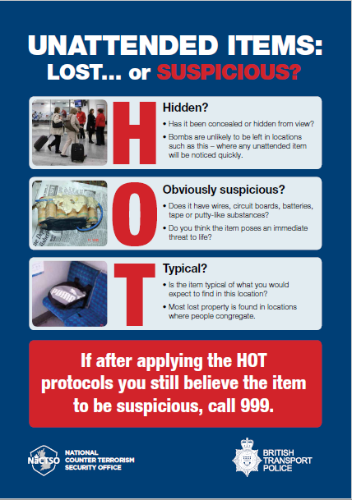

A6 Suspicious packages
Indicators of suspicious packages include:
- unexpected item, especially if hand delivered
- a padded envelope (Jiffy Bag) or other bulky package
- additional inner envelope or other contents that may be difficult to remove
- oily stains or discolouration
- protruding wires
- envelope with powder, or powder-like residue
- excessive tape or string
- oddly shaped or lopsided
- unusual weight for its size
- strange odour
- excessive postage
- addressed to a title (e.g. Operations Manager) rather than a named individual
- no return address
- misspelt words
- address poorly printed or written
- restrictive address, e.g. ‘confidential’, ‘personal’ or ‘only to be opened by’
- small holes in the envelope or wrapping

Inform Estate Patrol using the emergency number 01392 72 2222 or via the SafeZone app.

A7 Cordon distances
Most terrorist bombs take the form of Improvised Explosive Devices (IEDs). Their means of delivery and the associated minimum cordon distances are shown below:

Vehicle (lorry) 400 metres
Vehicle or wheelie bin (up to the size of a car) 200 metres
Person-borne / Parcel (e.g., rucksack) 100 metres

If buildings near the cordons are not evacuated, the occupants should be informed of the incident and advised to stay away from windows. They should also be notified when the ‘all clear’ is given.

Appendix B Chemical, biological and radiological (CBR) incidents

B1 Action to be taken
If a member of staff or student finds a suspicious package, immediate contact should be made with Estate Patrol using the emergency number 01392 72 2222 or via the SafeZone app, as in A6 above. In the case of CBR contamination, the nature of the incident might not be known straightaway. For example, an Improvised Explosive Device (IED) explosion might also involve the release of a hazardous material.

It is important to minimise the spread of the contaminant by switching off equipment that circulates air (e.g. heating, ventilation and air conditioning systems, computers and fans), having due regard for laboratory safety systems.

If an incident occurs outside, the occupants of nearby buildings should be asked to close all windows and doors, and to switch off any equipment that draws air into the building.

The University has a Building Energy Management System (BEMS) that it uses to remotely control heating, ventilation and air conditioning within buildings. The BEMS Controls Engineer may be able to assist with switching off this equipment. Local manual controls situated within buildings may also be used.

People should only be allowed to leave the evacuation area after the emergency services have assessed and advised them, regardless of whether individuals believe they have been exposed to the hazard, or not.

B2 Decontamination planning checklist
The checklist below is reproduced from “Strategic National Guidance - The decontamination of buildings, infrastructure and open environment exposed to chemical, biological, radiological substances or nuclear materials”, Appendix C published by HM Government, March 2017.

The following is a list of issues for consideration when planning the decontamination process:  - Have sampling and a detailed evaluation been conducted to determine the exact nature and extent of the contamination?  - Is decontamination required?  - Are the buildings/items worth saving?  - Have those directly affected been consulted?  - Can personal items of high value to the owner be decontaminated?  - Should the buildings be sealed?  - If the buildings are to be demolished, have specialist agencies and the local authority been consulted on how this will be tackled to limit the spread of contamination to surrounding buildings and areas?  - If the buildings are to be decontaminated have specialist agencies been consulted on how the work will be carried out safely and effectively, so that the buildings can be reoccupied as soon as possible?  - Have contractors been engaged on behalf of the building’s owner/occupier to carry out the decontamination?  - Has it been decided who will cover the cost of engaging any specialist contractors? | - Has it been decided who will monitor the progress of the work and compile regular reports to be circulated to staff, the public and neighbouring owners/occupiers?  - Has it been decided who will have overall control of the decontamination process, including health and safety issues?  - Based on the sampling and evaluation results, and advice from specialist agencies and advisers, has a detailed plan for decontamination been drawn up? If so, does it include:  - the nature and extent of the contamination.  - any structural damage to the building(s).  - characteristics of each building, its systems and contents.  - the precise objectives for decontamination of each building, its systems and contents.  - whether decontamination of movable items is to be done on-site or off-site and the arrangements for moving them safely.  - whether any items are to be disposed of and if so, the agreed methods of decontamination or remediation (detailed records should be kept of contaminants and their treatment);

- how the outcome of decontamination will be assessed to validate the process, including arrangements for sampling and analysis.  - whether there are any aspects of the building’s age, location, surrounding environment, infrastructure or intended use that may affect the way decontamination is carried out (issues to be considered include the historic landscape and the ecological or archaeological value of the environment).  - whether it has been decided how the decontamination process will be prioritised if there is widespread contamination and if the building comprises several premises.  - whether checks have been carried out to establish if any contaminants already exist in the contaminated building (for example, asbestos or lead);  - whether suitable and secure temporary buildings will be provided to accommodate contractors and store equipment and materials.  - whether there are facilities for decontaminating the staff engaged in the work.  - whether the health and environmental consequences of the decontaminants or remediation options have been addressed. | - whether arrangements have been made to manage, transport and dispose of the waste material.  - whether, if more than one contractor is working on the project, plans have been made to ensure a consistent approach to removing contaminated materials?  - availability of utilities (e.g. water and electricity) for decontamination operations.  - Have relevant bodies been consulted and any necessary clearances or approvals obtained?  - Have plans been made and who will decide when the building is safe for reoccupation?

B3 Outline of the decontamination process
The flow chart below is reproduced from “Strategic National Guidance - The decontamination of buildings, infrastructure and open environment exposed to chemical, biological, radiological substances or nuclear materials”, Appendix D published by HM Government, March 2017.

Recovery activities normally take place on the site after the response is completed, and emergency services have completed any investigations required. This flow chart details the key stages and decisions in this process:
Is contamination suspected?
Limit the spread of any potential contamination and prevent public access
Investigate by sampling, monitoring and analysis
Is contamination confirmed?
Are contamination levels a danger to health or the environment?
Continue to limit the spread of contamination and prevent public access
Investigate and consider decontamination and remediation options. Set standards for decontamination
Is decontamination possible?
Put in place permanent arrangements to secure the site long term
Decontaminate and dispose of waste
Check effectiveness by sampling, monitoring and analysis
Have decontamination standards been met?
Reoccupy
Repeat process and/or consider alternative methods
Y
Y
Y
Y
N
N
N
N
Y

Appendix C Firearm and weapon attacks
Although firearm and weapon attacks do not occur often, Universities and schools in many countries have experienced such incidents.

If a firearm or weapon attack occurs on campus, the police will require the following information:
- Location
- Number of perpetrators
- Description of weapon (e.g. handgun, rifle, knife, vehicle)
- Whether the perpetrators are moving in any direction

CCTV should be used to monitor the situation where possible.

All available channels of communication should be used to warn people of the danger and to encourage them to avoid public areas or access points. Response strategies include evacuation if there is an opportunity to escape. National Counter Terrorism policing has released a short public information film called ‘Stay Safe: Firearms and Weapons Attack’. The film outlines recommended options for members of the public who find themselves in the vicinity of a firearms or weapons attack. The main points (Run, Hide, Tell), are set out in a leaflet published by Counter Terrorism Policing which is reproduced on the next page.
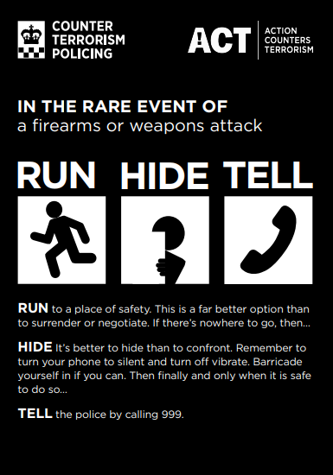

Appendix D Shelter Area Assessment
<<removed>>

Appendix E Indoor Shelter Area Registration Form
First Name | Last Name | ID No. or date of birth | Staff /  Student /  Visitor | Faculty/  Service/  Department | Special requirements | Final departure date & time

Appendix F Air Ambulance landings
If an Air Ambulance needs to land, the following sites should be considered by the University Incident Manager:

- Field adjacent to Prince of Wales Road, opposite Old Library
- St Luke’s Quad

On notification that an Air Ambulance will be despatched, Estate Patrol should manage the landing site:
- Put on a high visibility vest
- Clear the landing site and prevent entry
- For night landings, use of floodlights (where available) on the landing area speeds the landing process
- Find something to wave (paper or high visibility vest, etc)
- Wave and keep waving with big movements until it’s obvious the pilot has seen you
- Vacate the area when the helicopter is approaching
- Kneel down to avoid being blown over by the down draught
- Turn your eyes away and shield them from any debris which may be blown by the rotor blades
- Don’t approach the helicopter - wait for the crew to come to you

Appendix G ETHANE and SBAR reporting forms

G1 ETHANE form
To be used by the University’s emergency responders when providing situation reports. An electronic version of this form is available in the JESIP app.
Mnemonic | Guidance | Report
Exact location | - Nearest junction, or  - Exact address, or  - what3words
Type of incident | - Fire, explosion, traffic accident, etc?  - Any indication of terrorism?
Hazards | - Hazards present or suspected  - Is evacuation or shelter-in-place necessary and safe?
Access routes | - Which routes are safe to use?  - Clarify routes which are blocked  - Nominate the RVP (does it need to be searched)?
Number of casualties | - List type and severity  - Approximate number of dead, injured, survivors and witnesses
Emergency services | - List those present and those required  - Conduct a joint dynamic hazard assessment with the emergency services (if present)
Completed by: .......................................................... Date .................................. Time ..............................

G2 SBAR form
This is a structured communication tool which may be used when requesting or receiving a request for assistance.
S | Situation What is happening at the scene?
- State your name and role
- There is a ________________ (fire, collapsed person..)
- At ______________________ (exact location)
- The current situation is __________________ (ETHANE)
B | Background Any additional information?
- Information about the lead up to the incident?
- What measures have been taken so far?
- Is anything else happening in the vicinity that is relevant?
A | Assessment What do you think is happening with this incident?
- Is the situation stable, deteriorating or improving?
- What might happen next?
R | Recommendation / Requirement What do you think needs to be done / what do you require?
- Explain what you need
- If attendance at the scene is required, be specific about where, when and who to meet
- Ask if there is anything else you can do before the other staff member arrives
- Exchange contact details

Appendix H Activity Log
Start the log by noting the time the incident was reported to you, and plan was invoked, the time the incident was declared and actions taken so far.
DATE & TIME | ACTIVITY  Activity, Decision, Instruction or Briefing (A, D, I or B) | ACTION | OWNER
e.g.17/05/23 12:20 | B - received notification of fire at Geoffrey Pope | Sent A3 and A4 to assess the situation | F Smith

Completed by ................................................................................

Appendix I Call Management Log
Following an incident, it may be necessary to call a variety of people, both internal and external to the organisation. The table below outlines some of the information that needs to be captured in order to monitor calls:
Person Called & Organisation | By Whom | Date & Time | Response/Outcome

Completed by ......................................................................

Appendix J Casualty List
NB: Accident/Near Miss Report Forms should always be completed.

NAME OF CASUALTY | DETAILS OF INJURY | COMMENT  (e.g. taken to hospital by ambulance) | INFORMATION PROVIDED BY [NAME]

Completed by .................................................................. Date ……………………………. Time …………………………….

Appendix K Dynamic risk assessment example
The dynamic risk assessment shown below was prepared during an exercise in response to a fictitious scenario. It is included as a worked example.
FACULTY | EXAMPLE | DEPARTMENT | Stocker Road
DATE | EXAMPLE

HAZARD  (something with the potential to cause harm) | EXERCISE SCENARIO Opening of pedestrian zone – Stocker Road – due to RTA involving 2x students.  In addition, there is an unconfirmed incident occurring in Geoffrey Pope Building and the fire alarm has been sounded and emergency services have been called.  The Silver incident commander has requested a dynamic risk assessment of the site, to safely open Stocker Road to remove traffic from North Park Road.

Risks – the things that you can “foresee” / imagine going wrong and how this could happen
A | Farmers Market currently taking place on the Piazza increasing the volume of staff / students and visitors using the Stocker Road area
B | Students are new to campus (7th October) and will not be expecting the Stocker Road to be open to traffic.
C | Stocker Road feed onto Rennes Drive – Cyclists and Pedestrians will not be aware of traffic approaching from the right.
D | Cars leaving car parks A&B heading down Rennes Drive will not be aware of traffic emerging from the right
E | Emergency services arriving to the scene in GP will need clear access to the top of stocker road – we need to ensure that all cars coming down Stocker Road are kept moving.
F | Food Wagon on INTO side of road

ACTION PLAN – things that need to happen now to control / reduce risk further

Risk | Further Action/Training Required To Control Risk
A | Consider closing the Farmers Market to reduce volume of people out on Stocker Road. Also remove food wagon. Remove bollards at top and bottom (EP have keys)
 | Traffic Management team to be installed at the top and bottom of Stocker Road, emergency signage to be displayed
 | Traffic Management team to be placed on Rennes Drive to slow and stop traffic coming from Rennes Drive
 | Cyclists to be asked to dismount before heading down Stocker Road
 | Staff in high vis / recognisable PPE to be placed on Stocker Road to create a safe pedestrian crossing point (bollards / chapter 8’s may be needed) to usher students and staff across the road at one point. More staff may be required for this.
 | Staff also to be placed near forum and INTO, to let students know as soon as they leave the building that the Stocker Road now has a crossing point in place
 | Radios will be needed for people on both ends of Stocker Road and on the pedestrian crossing point to ensure they can communicate effectively regarding traffic flow
 | Consider the communications to students approaching from Queens Drive / Peter Chalk
 | Consider an all staff email asking staff to keep away from the Piazza at this time.
 | Consider how / who to keep the students moving to ensure that multiple people do not congregate on the piazza

ASSESSMENT SIGN OFF | Assessor’s Name

Table 1a
Consequence Scoring Matrix
 |  | 1 | 2 | 3 | 4 | 5
Descriptor | ref | Insignificant | Minor | Moderate | Major | Catastrophic
Injury | a | Minor injury not requiring first aid | Minor injury or illness, first aid treatment needed | Absent for more than 3 days | RIDDOR reportable Major injuries, or long-term incapacity / disability (loss of limb) | Death or major permanent incapacity
Student Experience | b | Unsatisfactory experience -resolved | Unsatisfactory experience - readily resolvable | Mismanagement -short term effects | Mismanagement long term effects | Totally unsatisfactory outcome or experience
Complaint / Claim Potential | c | Locally resolved complaint | Justified complaint | Below excess claim. Justified complaint involving lack of appropriate care | Claim above excess level. Multiple justified complaints | Multiple claims or single major claim
Objectives / Projects | d | Insignificant cost increase / schedule slippage. Barely noticeable reduction in scope or quality | < 5% over budget / schedule slippage. Minor reduction in quality / scope | 5 -10% over budget / schedule slippage. Reduction in scope or quality requiring client approval | 10 - 25% over budget / schedule slippage. Doesn't meet secondary objectives | > 25% over budget / schedule slippage. Doesn't meet primary objectives
Service / Business Interruption | e | Loss / interruption > 1 hour | Loss / interruption > 8 hours | Loss / interruption > 1 day | Loss / interruption > 1 week | Permanent loss of service or facility
Human Resources / Organisational Development | f | Short term low staffing level temporarily reduces service quality (< 1 day) | Ongoing low staffing level reduces service quality | Late delivery of key objective / service due to lack of staff (recruitment, retention or sickness). Minor error due to insufficient training. Ongoing unsafe staffing level | Uncertain delivery of key objective / service due to lack of staff. | Non delivery of key objective / service due to lack of staff. Loss of key staff. Very high turnover.
Financial | g | Small loss(> £100) | Loss > £1,000 | Loss > £10,000 | Loss > £100,000 | Loss > £1,000,000
Inspection / Audit | h | Minor recommendations. Minor non-compliance with standards | Recommendations given. Non-compliance with standards | Challenging recommendations. Non-compliance | Enforcement Action. Multiple challenging recommendations. Major non-compliance | Prosecution. Severely critical report
Adverse Publicity / Reputation | i | Rumours | Local Media - short term | Local Media - long term | National Media < 3 Days | National Media > 3 Days. MP Concern (Questions in House)

Table 1b
Likelihood Score

 | 1 | 2 | 3 | 4 | 5
Descriptor | Rare | Unlikely | Possible | Likely | Almost Certain
Frequency | Not expected to occur for years | Expected to occur at least annually | Expected to occur at least monthly | Expected to occur at least weekly | Expected to occur at least daily
Probability | < 1% | 1 – 5% | 6 – 20% | 21 – 50% | > 50%
Probability | Will only occur in exceptional circumstances | Unlikely to occur | Reasonable chance of occurring | Likely to occur | More likely to occur than not

Table 1c Risk Score

Likelihood | Consequence
Likelihood | 1  Insignificant | 2  Minor | 3  Moderate | 4  Major | 5  Catastrophic
1 - Rare | 1 | 2 | 3 | 4 | 5
2 - Unlikely | 2 | 4 | 6 | 8 | 10
3 - Possible | 3 | 6 | 9 | 12 | 15
4 - Likely | 4 | 8 | 12 | 16 | 20
5 - Almost  Certain | 5 | 10 | 15 | 20 | 25

Appendix L Further resources
Resilience in Higher Education: Third edition – 2019
Published by AUCSO
A copy is available from the Insurance, Audit & Risk Team, Lafrowda House (email buscont@exeter.ac.uk)

Protecting Against Terrorism – Third Edition
Issued 2010 by CPNI, available from:
https://www.cpni.gov.uk/system/files/documents/5a/c9/Protecting-Against-Terrorism.pdf

ProtectUK
A dynamic platform, committed to equipping organisations with the necessary tools and insights to navigate the ever-changing landscape of protective security and effectively evaluate and mitigate terrorism threats.

Strategic National Guidance: Decontamination of people exposed to chemical, biological, radiological or nuclear (CBRN) substances or material
Issued January 2006 by the Cabinet Office, available from:
https://www.gov.uk/government/publications/strategic-national-guidance-the-decontamination-of-people-exposed-to-cbrn-substances-or-material

Strategic National Guidance: The decontamination of buildings, infrastructure and open environment exposed to chemical, biological, radiological or nuclear materials
Issued June 2013 by the Cabinet Office, updated March 2017, available from:
https://www.gov.uk/government/publications/strategic-national-guidance-the-decontamination-of-buildings-infrastructure-and-open-environment-exposed-to-chemical-biological-radiological-or-nuclear-materials

Crisis Management for Terrorist Related Events
Guidance issued by the National Protective Security Agency
https://www.cpni.gov.uk/crisis-management-terrorist-related-events

Counter terrorism first aid awareness
Issued November 2021 by ProtectUK
https://www.protectuk.police.uk/advice-and-guidance/response/counter-terrorism-first-aid-awareness?mtm_campaign=FAidC

Protective Security and Preparedness for Education Settings
Issued April 2024 by the Department for Education, available from:
https://www.gov.uk/government/publications/protective-security-and-preparedness-for-education-settings

Contents
SECTION A UNIVERSITY INCIDENT MANAGER 1
EMERGENCY PROCEDURES AND TASKS 1
SECTION B SCHEMATIC SHOWING RESPONDERS’ ROLES AND RESPONSIBILITIES 4
SECTION C GUIDANCE 5
1 Aim 5
2 Objectives 5
3 Scope 5
4 Campus profile 5
4.1 Map of Streatham Campus 5
4.2 Zone Map of Streatham Campus 7
4.3 Map of St Luke’s Campus 9
5 Invoking the Plan 10
5.1 Alert cascade 10
5.2 Evacuation, shelter and dispersal 11
6 Emergency Response Phase 13
6.1 Command and control structure 13
6.2 Implementation 15
6.3 Communication 16
6.4 Traffic management 17
6.5 Crime prevention 18
6.6 Provision for groups with specific needs 18
6.7 Cordons 18
6.8 Evidence 18
6.9 Stand down 19
6.10 Hot Debrief 19
7 Recovery Phase 19
SECTION D PLAN ADMINISTRATION 20
SECTION E APPENDICES 21
Appendix A Bomb Threats 21
A1 Introduction 21
A2 Written threats 21
A3 Telephone, email and social media threats 21
A4 Carrying out a search 25
A5 Unattended items 26
A6 Suspicious packages 28
A7 Cordon distances 28
Appendix B Chemical, biological and radiological (CBR) incidents 29
B1 Action to be taken 29
B2 Decontamination planning checklist 30
B3 Outline of the decontamination process 31
Appendix C Firearm and weapon attacks 33
Appendix D Shelter Area Assessment 35
Appendix E Indoor Shelter Area Registration Form 36
Appendix F Air ambulance landings 37
Appendix G ETHANE and SBAR reporting forms 38
G1 ETHANE form 38
G2 SBAR form 39
Appendix H Activity Log 40
Appendix I Call Management Log 41
Appendix J Casualty List 42
Appendix K Dynamic risk assessment example 43
Appendix L Further resources 46

END

Exact location, Type of incident, Hazards, Access, Number of casualties, Emergency Services
Situation, Background, Assessment, Recommendation / Requirement

